MINISTRY OF EDUCATION AND TRAINING
UNIVERSITY OF ECONOMICS AND FINANCE
HO CHI MINH CITY
---------------------------


FINAL PROJECT REPORT
SOFTWARE QUALITY VERITIFICATION
TOPIC: ONLINE SALES MANAGEMENT SYSTEM

Class: 252.ITE1231E.A02E
Instructor: MSc. Nguyễn Ngọc Tú

Performed by Student:
Hoàng Văn Thiên | 22D1ITE-SWE03 | 225051915
Nguyễn Thành Đạt | 22D1ITE-SWE03 | 225050896
Lê Quang Duy | 22D1ITE-SWE03 | 225051169

Ho Chi Minh City, January 2026

ACKNOWLEDGEMENT
We would like to express our sincere appreciation to our instructor, MSc. Hoàng Văn Hiếu, for his continuous guidance, valuable feedback, and dedicated support throughout the Application Development of Advanced Web course. His clear explanations, practical insights, and thoughtful suggestions greatly assisted our team in understanding complex web application development concepts and applying them effectively during the implementation of this project. The instructor’s guidance helped us approach the project in a structured and professional manner, from requirement analysis to system design and implementation.
We would also like to thank the University of Economics and Finance Ho Chi Minh City (UEF) for providing a supportive academic environment and sufficient learning resources. The facilities, learning materials, and technical infrastructure offered by the university created favorable conditions for our team to research, develop, and complete the Online Sales Management System in alignment with the course objectives.
In addition, we sincerely appreciate the cooperation and efforts of all team members involved in this project. Throughout the development process, team members actively collaborated, shared responsibilities, and supported one another in solving technical and organizational challenges. Although the workload and task complexity varied among members, each contribution played an important role in the completion of the system. This experience helped us improve not only our technical skills but also our communication, teamwork, and time management abilities.
Despite the limitations caused by time constraints and the academic scope of the course, we believe that this project reflects our learning progress and practical understanding of advanced web application development. The knowledge and experience gained from this project will serve as a valuable foundation for our future studies and professional careers in the field of software engineering.
Thank you very much!

LIST OF CONTENTS
LIST OF FIGURES v
LIST OF TABLES viii
CHAPTER 1. INTRODUCTION 1
1.1. Background and problem statement 1
1.1.1. Background 1
1.1.2. Problem Statement 1
1.2. Objectives 1
1.3. Scope and target audience 2
1.3.1. Target audience 2
1.3.2. Project scope 2
1.4. Limitations 2
1.5. Project significance 3
CHAPTER 2. LITERATURE REVIEW AND REQUIREMENTS 4
2.1. Technologies used 4
2.1.1. Backend technologies 4
2.1.2. Database management system Microsoft SQL Server 5
2.1.3. Object relational mapper Entity Framework Core 5
2.1.4. Frontend technologies 5
2.1.5. Development tools and version control 6
2.2. System design analysis 6
2.2.1. Design patterns 7
2.2.2. Software engineering methodology 7
2.3. Requirement analysis 8
2.3.1. Functional requirements 8
2.3.2. Non functional requirements 8
2.4. Diagram 10
2.4.1. Use case diagram 10
2.4.2. Activity diagram 22
2.4.2.1. Sales staff order process 22
2.4.2.2. Warehouse import products 23
2.4.2.3. Admin generate revenue report 24
2.4.3. Sequence diagram 25
2.4.3.1. Sales staff create order 25
2.4.3.2. Warehouse import products 26
2.4.3.3. Admin generate revenue report 27
CHAPTER 3. SYSTEM DESIGN 29
3.1. Database design 29
3.1.1. Authentication and authorization 29
3.1.2. Sales purchasing and inventory 30
3.1.3. Human resources and attendance 31
3.1.4. System configuration and lookup 32
3.1.5. Expense management 32
3.1.6. Entity relationships and descriptions 33
3.2. Website mockup 37
3.2.1. UI rules and conventions 37
3.2.2. Login mockup 37
3.2.3. Sales-Staff 39
3.2.4. Warehouse 43
3.2.5. Admin 46
3.2.6. Admin module mockups 47
3.3. System architecture 51
CHAPTER 4. IMPLEMENTATION AND RESULTS 52
4.1. Development environment and tools 52
4.2. Step-by-Step installation guide 52
4.2.1. System preparation and source code retrieval 52
4.2.2. Database configuration 54
4.2.3. Database initialization using migrations 54
4.2.4. Running the application 55
4.3. Key code snippets and explanation 56
4.3.1. Backend permission handling in controller layer 57
4.3.2. Dynamic permission matrix in presentation layer 58
4.3.3. Detailed processing workflow 59
4.3.4. Security enforcement mechanism 59
4.3.5. Conclusion of RBAC implementation 60
4.3.6. Verification and testing results 60
4.4. Screenshots of main features 61
4.4.1. Authentication and authorization 61
4.4.1.1. Login page 61
4.4.1.2. Login success and redirect 61
4.4.1.3. Authorization check and access denied 61
4.4.2. Admin main features 62
4.4.2.1. Admin dashboard 62
4.4.2.2. User management 63
4.4.2.3. Role management 63
4.4.2.4. Permission matrix or access control settings 64
4.4.2.5. Employee management 65
4.4.2.6. Attendance tracking 65
4.4.2.7. Expense management 66
4.4.2.8. Export reports to Excel 67
4.4.2.9. System configuration 68
4.4.3. Sales Staff main features 70
4.4.3.1. Sales dashboard 70
4.4.3.2. Product browsing and searching 70
4.4.3.3. Product detail view 71
4.4.3.4. Customer management 72
4.4.3.5. Customer detail 72
4.4.3.6. Customer create 73
4.4.3.7. Create invoice 74
4.4.3.8. Invoice calculation and total 74
4.4.3.9. Invoice status workflow 75
4.4.3.10. Print invoice 77
4.4.3.11. Error handling and validation 78
4.4.4. Warehouse main features 78
4.4.4.1. Warehouse dashboard overview 78
4.4.4.2. Inventory monitoring 79
4.4.4.3. Create stock import receipt 80
4.4.4.4. Inventory updated after import 80
4.4.4.5. Stock movements history 81
4.4.4.6. Stock reorder alert 82
4.5. Conclusion and future work 82
4.5.1. Achievements 82
4.5.2. Limitations 84
4.5.3. Suggestions for future enhancements 85
APPENDIX 86
REFERENCES 87
TASK DIVISION AND CONTRIBUTION SUMMARY 88

LIST OF FIGURES
Figure ‎2.1-1: MVC architecture 4
Figure ‎2.1-2: SQL server 5
Figure ‎2.1-3: Code first approach 5
Figure ‎2.1-4: Frontend technologies 6
Figure ‎2.1-5: Development tools 6
Figure ‎2.4-1: Use case diagram 10
Figure ‎2.4-2: Order process diagram 22
Figure ‎2.4-3: Import product diagram 23
Figure ‎2.4-4: Generate revenue report diagram 24
Figure ‎2.4-5: Create order diagram 25
Figure ‎2.4-6: Import products diagram 26
Figure ‎2.4-7: Generate revenue report diagram 27
Figure ‎3.1-1: Authentication and authorization erd 30
Figure ‎3.1-2: Sales purchasing and inventory 31
Figure ‎3.1-3: Human resources and attendance erd 32
Figure ‎3.1-4: System configuration erd 32
Figure ‎3.1-5: Expense management erd 33
Figure ‎3.2-1: Login mockup 38
Figure ‎3.2-2: Sales staff - customer list mockup 39
Figure ‎3.2-3: Sales staff - add new customer mockup 39
Figure ‎3.2-4: Sales staff - edit customer mockup 40
Figure ‎3.2-5: Sales staff – product list mockup 41
Figure ‎3.2-6: Sales staff - invoice list mockup 42
Figure ‎3.2-7: Sales staff - invoice details mockup 42
Figure ‎3.2-8: Sales staff - create new invoice mockup 43
Figure ‎3.2-9: Warehouse – inventory list mockup 44
Figure ‎3.2-10: Warehouse – stock entry mockup 45
Figure ‎3.2-11: Admin - dashboard mockup 46
Figure ‎3.2-12: Admin – financial overview report mockup 47
Figure ‎3.2-13: Admin – user account management mockup 48
Figure ‎3.2-14: Admin - group permission matrix mockup 49
Figure ‎3.2-15: Admin - stock movements mockup 50
Figure ‎4.2-1: Cloning the project repository in visual studio 53
Figure ‎4.2-2: Project structure in solution explorer 54
Figure ‎4.2-3: Connection string configuration in appsettings.json 54
Figure ‎4.2-4: Applying migrations via package manager console 55
Figure ‎4.2-5: Application login interface 56
Figure ‎4.2-6: Administrator dashboard overview 56
Figure ‎4.3-1: Controller layer code 57
Figure ‎4.3-2: Presentation layer code 58
Figure ‎4.3-3: Dynamic group permissions matrix interface 59
Figure ‎4.3-4: Access denied message 60
Figure ‎4.4-1: Login screen 61
Figure ‎4.4-2: Successful login and role-based landing page 61
Figure ‎4.4-3: Access denied when permission is missing 62
Figure ‎4.4-4: Admin dashboard 62
Figure ‎4.4-5: User management 63
Figure ‎4.4-6: Role management 64
Figure ‎4.4-7: Permission matrix configuration 64
Figure ‎4.4-8: Employee management 65
Figure ‎4.4-9: Attendance tracking 66
Figure ‎4.4-10: Expense management 66
Figure ‎4.4-11: Executive reporting dashboard 67
Figure ‎4.4-12: Exported Excel report 68
Figure ‎4.4-13: System settings and branding configuration 68
Figure ‎4.4-14: Sales dashboard 70
Figure ‎4.4-15: Product browsing and search 71
Figure ‎4.4-16: Product details 71
Figure ‎4.4-17: Customer list 72
Figure ‎4.4-18: Customer detail 73
Figure ‎4.4-19: Customer create 73
Figure ‎4.4-20: Create invoice 74
Figure ‎4.4-21: Invoice calculation and total 75
Figure ‎4.4-22: Invoice unpaid status 75
Figure ‎4.4-23: Invoice partially paid status 76
Figure ‎4.4-24: Invoice paid status 76
Figure ‎4.4-25: Invoice cancelled status 77
Figure ‎4.4-26: Print invoice 77
Figure ‎4.4-27: Error handling and validation 78
Figure ‎4.4-28: Warehouse dashboard 79
Figure ‎4.4-29: Inventory monitoring 79
Figure ‎4.4-30: Create stock import receipt 80
Figure ‎4.4-31: Inventory updated after import 81
Figure ‎4.4-32: Stock movements history 81
Figure ‎4.4-33: Stock reorder alert 82

LIST OF TABLES
Table ‎2.4-1: UC-1 Login 10
Table ‎2.4-2: UC-02 Sign out 12
Table ‎2.4-3: UC-03 Search for products 13
Table ‎2.4-4: UC-04 Invoice management 14
Table ‎2.4-5: UC-05 Customer management 15
Table ‎2.4-6: UC-06 Check inventory 16
Table ‎2.4-7: UC-07 Import goods 17
Table ‎2.4-8: UC-08 User management 18
Table ‎2.4-9: UC-09 Category management 19
Table ‎2.4-10: UC-10 Product management 20
Table ‎2.4-11: Statistical report 21
Table ‎3.1-1: Entity relationships and descriptions 33

OVERVIEW

Background and problem statement

Background
In recent years, the rapid growth of e-commerce has significantly changed the way businesses operate and interact with customers. Digital transformation has become an essential driver for growth, enabling companies to reach wider markets and streamline their operations. However, while large corporations have successfully adopted advanced management systems, the adoption rate among smaller entities remains limited due to resource constraints and technical barriers

Problem Statement
Many small and medium-sized enterprises (SMEs) still rely on manual processes, spreadsheets, or basic social media channels to manage their sales activities. Product information is often decentralized, inventory tracking is inaccurate, and order processing is time-consuming. These limitations lead to operational errors, inefficiency, and difficulties in tracking overall business performance.
To address these challenges, the Online Sales Management System is proposed as a web-based platform that provides a structured, modern, and automated solution for managing internal business operations. The system centralizes product management, inventory control, and order processing into a unified dashboard. By replacing disparate manual methods with a cohesive digital system, the project aims to enhance data consistency, improve operational speed, and provide business owners with better control over their sales activities.

Objectives
The primary objective of this project is to design and develop a complete internal e-commerce management system using the ASP.NET Core MVC framework. The project aims to achieve several specific goals. First, it seeks to create a centralized management platform where administrators can oversee products, categories, inventory, and user accounts efficiently. Second, the system implements strict role-based security, ensuring clear separation of duties between Sales Staff, Warehouse Staff, and Administrators to enhance data security and streamline workflows.
Furthermore, the project aims to automate essential processes such as order calculations and stock adjustments, thereby minimizing human errors that frequently occur in manual entry. From an academic perspective, this project serves as a practical application of advanced web development concepts, system architecture, and database design using Entity Framework Core, effectively fulfilling the learning outcomes of the course.

Scope and target audience

Target audience
Unlike public e-commerce websites designed for mass consumers, this system is engineered exclusively for internal users to facilitate business operations. The target audience is categorized into three distinct user groups with clearly defined responsibilities:
Sales Staff: Responsible for creating sales orders, managing customer profiles, confirming order statuses, and coordinating delivery.
Warehouse Staff: Duties involve monitoring inventory levels, importing new stock, and ensuring the accuracy of warehouse data.
Administrators: Possess full system access to manage employee accounts, assign roles, and configure system settings.

Project scope
In terms of scope, the project focuses on developing a web-based application tailored for the essential operational needs of a small-to-medium retail business. The system encompasses core modules including user authentication, product catalog management, inventory control, and order processing. The project strictly adheres to the requirements of an internal management tool rather than a public-facing store, focusing on the efficiency of backend operations.

Limitations
Due to the time constraints of the academic semester and available resources, the current implementation excludes several advanced features. Notably, there is no interface for end-customers to register or purchase directly; all interactions must be mediated through sales staff. Additionally, integrated online payment gateways are not part of the current scope, meaning transactions are recorded manually. The system is developed solely as a web application and does not support native mobile applications for Android or iOS platforms. Advanced automation features, such as AI-based forecasting, are also reserved for future development.

Project significance
Despite these limitations, the project holds significant practical value for small businesses by reducing reliance on manual paperwork and improving service speed. Academically, it demonstrates the team's capability to analyze complex business requirements and implement a structured, secure web application using modern Microsoft technologies. It provides a solid foundation for understanding enterprise software development lifecycles.

TEST PLAN

Technologies used
The selection of an appropriate technology stack is a critical factor in ensuring the stability, scalability, and maintainability of the Online Sales Management System. This section outlines the principal software development tools and frameworks chosen for the implementation of the system, along with the rationale for their selection and their specific roles within the overall architecture.

Backend technologies
The system’s backend is constructed using the ASP.NET Core Web App (Model–View–Controller), a modern and high-performance framework that facilitates a clean separation of concerns through the MVC architecture. In this architectural pattern, the Model is responsible for handling business logic and data structures, while the View component is created with the Razor View Engine to generate dynamic and responsive HTML pages. The Controller acts as the intermediary that processes incoming requests, interacts with the Model to retrieve or update data, and returns the appropriate View to the client. Furthermore, ASP.NET Core provides essential features such as built-in routing, dependency injection, and middleware support, enabling the system to remain scalable and maintainable. Complementing this, Entity Framework Core is utilized as the Object-Relational Mapper (ORM), which simplifies CRUD operations by allowing developers to interact with the database using C# objects instead of writing manual SQL queries.
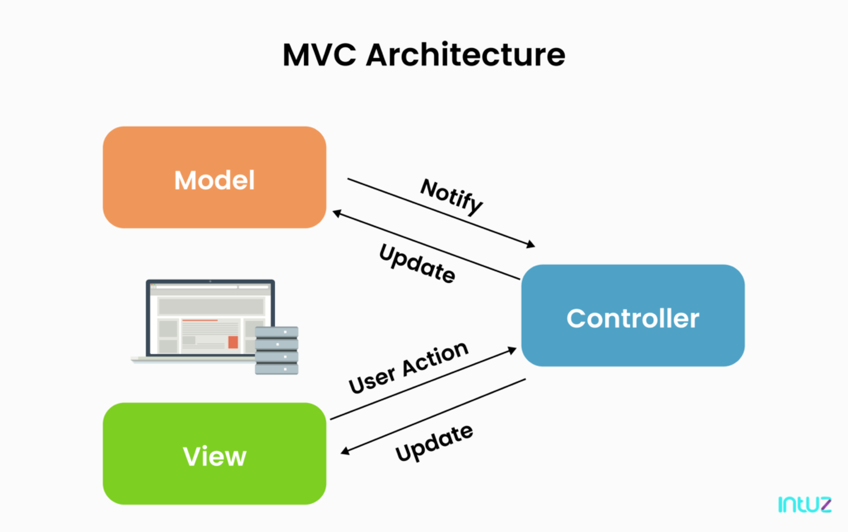
Figure ‎2.1-1: MVC architecture

Database management system Microsoft SQL Server
For data persistence, Microsoft SQL Server is employed as the primary Relational Database Management System (RDBMS). It is responsible for storing critical business data, including product catalogs, user credentials, inventory records, and sales transactions. SQL Server was chosen for its proven reliability, strong transaction support (ACID compliance), and seamless integration with the .NET ecosystem. It ensures that complex queries regarding sales reports and inventory checks are executed with optimal speed and accuracy.

Figure ‎2.1-2: SQL server

Object relational mapper Entity Framework Core
To facilitate efficient interaction between the application code and the database, Entity Framework Core (EF Core) is utilized as the Object-Relational Mapper. EF Core allows developers to manipulate data using C# objects and LINQ (Language Integrated Query) rather than writing raw SQL queries. This abstraction layer accelerates development speed and reduces the risk of SQL injection attacks. In this project, we leverage Code-First Migrations, allowing us to define the database schema directly from C# classes, ensuring strict consistency between the codebase and the database structure.
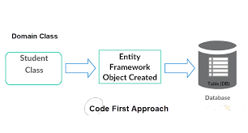
Figure ‎2.1-3: Code first approach

Frontend technologies
The user interface is developed using a combination of standard web technologies to ensure a responsive and intuitive user experience for Sales and Warehouse staff. HTML5 and CSS3 are utilized to provide the structural and stylistic foundation of the web pages. Bootstrap 5 is integrated as a powerful CSS framework chosen to ensure the application is responsive and mobile-friendly, allowing the layout to adapt seamlessly to tablets or desktop screens used in the store. Finally, JavaScript is employed to handle client-side interactivity, such as dynamic form validation and calculating order totals instantly before submission.
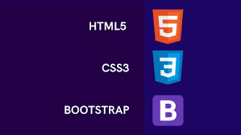
Figure ‎2.1-4: Frontend technologies

Development tools and version control
To support a professional development workflow, the team utilizes industry-standard tools throughout the software lifecycle. Microsoft Visual Studio 2022 serves as the comprehensive Integrated Development Environment (IDE), providing essential capabilities for coding, debugging, and managing project dependencies efficiently. For source code management and collaborative development, Git and GitHub are employed. Specifically, Git allows the team to track every modification through commit history, manage feature branches, and resolve code conflicts effectively, ensuring a smooth and organized teamwork process.

Figure ‎2.1-5: Development tools

System design analysis

Design patterns
To ensure the application is maintainable, scalable, and testable, the system architecture adheres to established software design patterns. The primary architectural pattern adopted is the Model-View-Controller (MVC). This pattern separates the application into three distinct components: the Model manages business logic and data structures; the View handles the user interface and data presentation; and the Controller processes incoming requests and acts as an intermediary. This clear separation of concerns allows for independent development and maintenance of each component, significantly reducing code complexity.
In addition to the MVC architecture, the system implements the Repository Pattern to abstract data access logic. Instead of the controllers interacting directly with the database context, they communicate through repository interfaces. This approach promotes loose coupling between the business logic and the data access layer. Furthermore, it enhances code reusability and simplifies unit testing, as the data layer can be easily mocked during the testing phase without requiring a live database connection.

Software engineering methodology
The development of the Online Sales Management System follows an Iterative and Incremental software engineering methodology, aligned with fundamental Agile principles. Rather than attempting to deliver the entire system in a single release, the project is broken down into smaller, manageable cycles. This approach supports gradual system evolution, allowing the team to validate functionality early, identify potential risks, and incorporate feedback continuously throughout the development lifecycle.
The development process is structured into sequential phases to ensure systematic progress. The initial phase focuses on System Foundation Setup, involving requirement analysis, database configuration, and the establishment of the ASP.NET Core architecture. Subsequent phases involve the incremental development of core modules, starting with Product and Inventory Management, followed by the Order Management Workflow. Once the core features are stable, the focus shifts to Administrative Functions such as user role management and system configuration. The final phase is dedicated to Testing and Refinement, where unit testing and performance optimization are conducted to ensure the system is robust and ready for deployment.

Requirement analysis

Functional requirements
Based on the analysis of the organization’s operational workflow, the system is designed to satisfy a set of essential functional requirements that support daily activities in a consistent and controllable manner. At the foundation level, the system must provide a secure authentication mechanism that allows authorized users to access the platform through login. Along with authentication, authorization is implemented through role-based access control to ensure that permissions are clearly separated among Administrators, Sales Staff, and Warehouse Staff. In addition to login, account registration is handled as an internal provisioning process rather than public self-registration; user accounts are created and maintained by the Administrator within the User Management module, and appropriate roles are assigned at the time of account creation to ensure controlled access and accountability.
In terms of sales operations, the system must enable Sales Staff to work efficiently from product selection to order completion. This includes searching and viewing product information, creating sales orders with accurate customer and order details, updating the progress and status of transactions, and coordinating delivery-related steps in alignment with the store’s process. The goal of these functions is to reduce manual effort, minimize input errors, and provide clear visibility into the state of each order throughout its lifecycle.
For inventory management, the system must support Warehouse Staff in maintaining accurate stock data and preventing discrepancies between physical inventory and recorded quantities. Core functions include monitoring stock levels in a timely manner, recording stock imports when goods are received, and validating inventory-related data to ensure consistency. These capabilities are necessary not only for warehouse operations but also for sales activities, as product availability directly affects order handling and customer commitments.
Finally, the administration module is designed to provide Administrators with comprehensive control over system configuration and operational oversight. Administrators must be able to manage user accounts, assign and adjust roles based on responsibilities, and supervise overall system usage to maintain stability and compliance with internal procedures. Together, these functional requirements ensure that the application supports business operations end-to-end while maintaining security, traceability, and clear separation of duties.

Non functional requirements
In addition to functional features, the system must adhere to strict non-functional standards to ensure quality and reliability. In terms of Performance, the application is required to handle multiple concurrent requests efficiently while maintaining fast response times to prevent operational delays during peak hours.
Regarding Security, data protection is paramount; therefore, all user passwords must be hashed before storage, and access to sensitive modules must be rigorously restricted based on user roles to prevent unauthorized data breaches.
Finally, to ensure Usability, the user interface is developed using the Bootstrap 5 framework. This ensures the application is fully responsive and provides a user-friendly, intuitive experience for non-technical staff across both desktop computers and tablet devices.

Diagram

Use case diagram
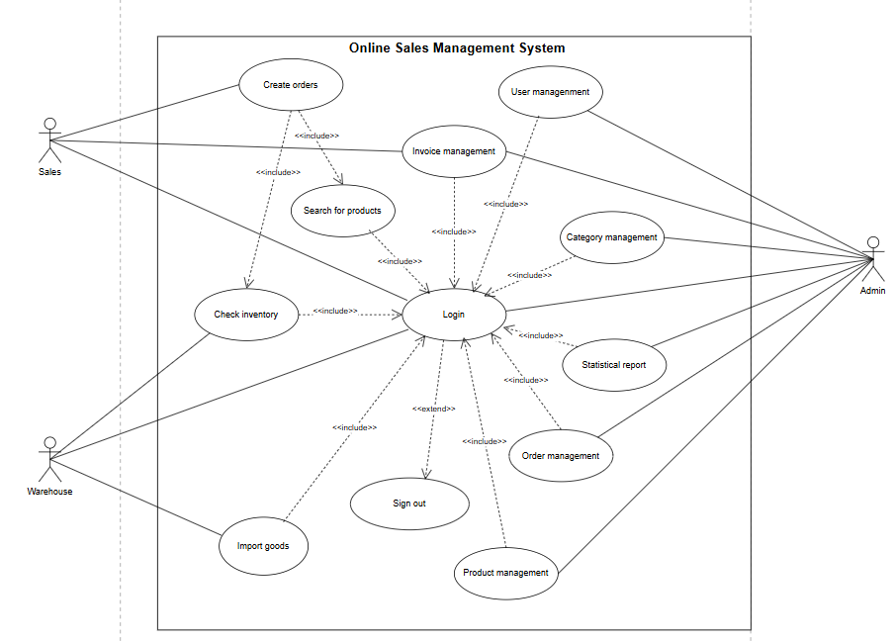
Figure ‎2.4-1: Use case diagram
The general Use Case Diagram illustrates the functional scope and interaction boundaries of the Online Sales Management System by defining the responsibilities of the three main actors involved in the digitized business workflow. The system architecture focuses on managing the entire lifecycle of sales transactions, in which Sales Staff initiate the process through product searching and order creation, while the inventory availability is managed by Warehouse Staff through stock checking and goods importation mechanisms.
Furthermore, the diagram highlights the pivotal role of the Admin in the strategic management process, which operates based on category and product configuration, leading to data-driven decision-making and the generation of statistical reports. Meanwhile, the Admin also maintains core administrative functions, specifically user management and invoice oversight, to ensure data integrity and security throughout the system’s operational lifecycle.
Table ‎2.4-1: UC-1 Login
ID and Name: | UC-1 Login
Created By: | Group 2
Primary Actor: | Sales Staff | Warehouse Staff | Admin
Description: | Allows users to access the Online Sales Management System by verifying their credentials (username and password) to ensure security and role-based access.
Trigger: | The User opens the application and the system displays the login screen.
Preconditions: | - PRE-1: The User has a registered account in the system.  - PRE-2: The User has valid credentials (Username and Password).
Postconditions: | - POST-1: The User is authenticated and successfully logged into the system.  - POST-2: The system displays the dashboard tailored to the User's role.  - POST-3: The User's session is established for security tracking.
Normal Flow: | - The User accesses the Online Sales Management System.  - The system displays the login form, requesting "Username" and "Password".  - The User enters their credentials.  - The User clicks the "Login" button.  - The system validates the credentials against the database.  - The system redirects the User to the main dashboard.  - The system records the login time in the system log.
Alternative Flows: | - The User enters an incorrect username or password.  - The system displays an error message "Invalid login credentials".  - Return to step 2 of the Normal Flow.

Table ‎2.4-2: UC-02 Sign out
ID and Name: | UC-02 Sign out
Created By: | Group 2
Primary Actor: | Sales Staff | Warehouse Staff | Admin
Description: | The User logs out of the Online Sales Management System to end their current session and ensure account security.
Trigger: | The User clicks the "Sign out" button on the navigation bar.
Preconditions: | - PRE-1: The User is currently logged into the system.
Postconditions: | - POST-1: The User's session is terminated.  - POST-2: The system redirects the User back to the Login screen.
Normal Flow: | - The User clicks the "Sign out" option from the user menu.  - The system processes the logout request.  - The system invalidates the current session token.  - The system redirects the User to the Login page.
Alternative Flows: | None.

Table ‎2.4-3: UC-03 Search for products
ID and Name: | UC-03 Search for products
Created By: | Group 2
Primary Actor: | Sales Staff | Admin
Description: | The Sales Staff views the product list to check product details such as price and current stock levels to assist customers during sales consultation.
Trigger: | The User selects the "Products" menu from the sidebar.
Preconditions: | - PRE-1: The User is logged in with valid permissions.  - PRE-2: Products exist in the system database.
Postconditions: | - POST-1: A list of products with real-time stock and price details is displayed to the User.
Normal Flow: | - The User clicks on the "Products" menu.  - The system queries the database for all active products.  - The system displays a table containing Product Name, Category, Price, and Stock Quantity.  - The User uses the search bar to find a specific item (optional).  - The system filters and displays the matching results.
Alternative Flows: | - The User searches for a keyword that does not exist.  - The system displays a message "No matching records found".

Table ‎2.4-4: UC-04 Invoice management
ID and Name: | UC-04 Invoice management
Created By: | Group 2
Primary Actor: | Sales Staff | Admin
Description: | The Sales Staff creates a new invoice to record a sales transaction. This process involves selecting customers, adding products, and saving the transaction.
Trigger: | The User selects "Invoices" and clicks the "Create Invoice" button.
Preconditions: | - PRE-1: The User is logged in as Sales Staff or Admin.  - PRE-2: The products to be sold must have sufficient stock.
Postconditions: | - POST-1: A new invoice is saved in the system.  - POST-2: The stock quantity of sold items is deducted from the inventory.  - POST-3: Revenue is recorded for the statistical report.
Normal Flow: | - The User accesses the "Create Invoice" screen.  - The User selects a Customer from the list (or chooses "Walk-in Customer").  - The User selects a Product from the dropdown list.  - The User enters the Quantity for the item.  - The system automatically calculates the Subtotal.  - The User clicks the "Save Invoice" button.  - The system saves the transaction and updates inventory.
Alternative Flows: | - The User enters a quantity greater than the current stock.  - The system displays a warning "Quantity exceeds available stock".  - The User adjusts the quantity.

Table ‎2.4-5: UC-05 Customer management
ID and Name: | UC-05 Customer management
Created By: | Group 2
Primary Actor: | Sales Staff | Admin
Description: | Allows users (Sales Staff or Admin) to manage customer profiles, including viewing the customer list and registering new customers for sales transactions.
Trigger: | The User selects "Customers" from the sidebar menu.
Preconditions: | - PRE-1: The User is logged in to the system.  - PRE-2: The User has valid permissions (Sales or Admin).
Postconditions: | - POST-1: A new customer record is created or updated in the database.  - POST-2: The customer is available for selection in the invoice creation screen.
Normal Flow: | - The User clicks the "Customers" menu from the sidebar.  - The system displays the list of existing customers.  - The User clicks the "Add Customer" button.  - The User enters customer details (Name, Phone Number, Address).  - The User clicks "Save".  - The system validates the data and saves the new customer profile.
Alternative Flows: | - The User leaves required fields (e.g., Name) empty during step.  - The system displays a validation error message.  - The User re-enters the correct information.

Table ‎2.4-6: UC-06 Check inventory
ID and Name: | UC-06 Check inventory
Created By: | Group 2
Primary Actor: | Warehouse Staff
Description: | The Warehouse Staff views the current stock levels of all products to monitor inventory availability and plan for replenishment.
Trigger: | The User selects the "Stock" or "Inventory" menu.
Preconditions: | - PRE-1: The User is logged in as Warehouse Staff.  - PRE-2: Products exist in the system database.
Postconditions: | - POST-1: The inventory list is displayed with the latest stock quantities (stock-on-hand).  - POST-2: (Optional) Low-stock products are identified (e.g., highlighted or filtered) for replenishment planning.
Normal Flow: | - The User clicks on the "Inventory" tab.  - The system retrieves product data including SKU/ID, Product Name, Category, and Stock Quantity.  - The system displays the inventory list sorted by product name or stock level.  - The User searches or filters products (optional).  - The User reviews stock details to identify low-stock items.
Alternative Flows: | None.

Table ‎2.4-7: UC-07 Import goods
ID and Name: | UC-07 Import goods
Created By: | Group 2
Primary Actor: | Warehouse Staff
Description: | The Warehouse Staff records the import of new goods from suppliers into the warehouse, increasing the system's stock count.
Trigger: | The User clicks the "Purchases" or "Import" button.
Preconditions: | - PRE-1: The User is logged in as Warehouse Staff.  - PRE-2: The product must already be defined in the system.
Postconditions: | - POST-1: The inventory quantity of the imported product is increased.  - POST-2: An import record is saved for history tracking.
Normal Flow: | - The User selects the "Add Purchase" function.  - The User selects the Supplier and the Product to import.  - The User enters the received Quantity.  - The User clicks "Submit".  - The system updates the inventory count in the database.  - The system confirms the successful import.
Alternative Flows: | - The User enters a negative or zero quantity.  - The system displays an error message.  - The User corrects the input.

Table ‎2.4-8: UC-08 User management
ID and Name: | UC-08 User management
Created By: | Group 2
Primary Actor: | Admin
Description: | The Admin manages system accounts for employees, including creating new accounts, assigning roles (Sales, Warehouse), and removing access.
Trigger: | The Admin selects "User Management" from the settings menu.
Preconditions: | - PRE-1: The User is logged in as Admin.
Postconditions: | - POST-1: User accounts are created, updated, or deleted.
Normal Flow: | - The Admin views the list of current users.  - The Admin clicks "Add New User".  - The Admin fills in the form (Username, Password, Role).  - The Admin clicks "Save".  - The system creates the account in the database.
Alternative Flows: | - The Admin enters a username that already exists.  - The system displays an error "Username already taken".

Table ‎2.4-9: UC-09 Category management
ID and Name: | UC-09 Category management
Created By: | Group 2
Primary Actor: | Admin
Description: | The Admin creates and manages product categories to organize items in the system (e.g., Electronics, Fashion).
Trigger: | The Admin selects the "Categories" menu.
Preconditions: | - PRE-1: The User is logged in as Admin.
Postconditions: | - POST-1: A category is created/updated/deactivated successfully and stored in the database.  - POST-2: The category list is refreshed and available for product assignment.
Normal Flow: | - The Admin opens the "Categories" module.  - The system displays the current category list.  - The Admin clicks "Add Category".  - The Admin enters category information (Name, Description, Status).  - The Admin clicks "Save".  - The system validates the input (e.g., required fields, unique name).  - The system saves the category and displays a success message.
Alternative Flows: | None.

Table ‎2.4-10: UC-10 Product management
ID and Name: | UC-10 Product management
Created By: | Group 2
Primary Actor: | Admin
Description: | The Admin defines and updates product specifications such as name, price, image, and description.
Trigger: | The Admin selects "Products" and clicks "Add Product".
Preconditions: | - PRE-1: The User is logged in as Admin.
Postconditions: | - POST-1: Product information is saved to the catalog.
Normal Flow: | - The Admin opens the "Add Product" form.  - The Admin enters product details (Name, Unit Price, Image).  - The Admin assigns the product to a Category.  - The Admin clicks "Save".  - The system adds the new product to the database.
Alternative Flows: | None.

Table ‎2.4-11: Statistical report
ID and Name: | UC-11 Statistical report
Created By: | Group 2
Primary Actor: | Admin
Description: | The Admin views visual reports and charts regarding business performance, such as total revenue, sold quantities, and inventory status.
Trigger: | The Admin clicks on the "Reports" menu.
Preconditions: | - PRE-1: The User is logged in as Admin.  - PRE-2: Transaction data exists in the system.
Postconditions: | - POST-1: Analytical data is displayed via charts or tables.
Normal Flow: | - The Admin selects the type of report (e.g., Sales Report).  - The Admin selects the date range (Start Date - End Date).  - The system processes the data from invoices.  - The system renders charts and tables summarizing the results.
Alternative Flows: | - The system finds no transactions for the selected period.  - The system displays "No data available".

Activity diagram

Sales staff order process
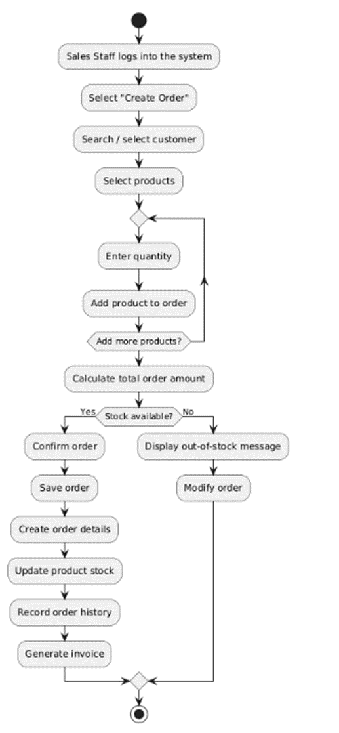
Figure ‎2.4-2: Order process diagram
The activity diagram illustrates the sequential workflow for the Order Creation process performed by the Sales Staff. The process commences with the staff member logging into the system and selecting the "Create Order" function. Subsequently, the user searches for and selects the appropriate customer profile to associate with the new order.
Following customer selection, the workflow enters an iterative phase where the staff selects products and specifies the required quantities. A loop structure is implemented at the "Add more products?" decision point, enabling the user to add multiple items to the order basket before proceeding. Once the product selection is finalized, the system automatically calculates the total order amount.
A critical validation step follows, where the system checks the availability of stock for the selected items. If the stock is insufficient, the system displays an out-of-stock message and prompts the user to modify the order. Conversely, if the stock is available, the process proceeds to the confirmation phase. The system saves the order, creates detailed order records, and automatically updates the product stock levels in the database. Finally, the order history is recorded, and an invoice is generated, marking the successful conclusion of the transaction.

Warehouse import products
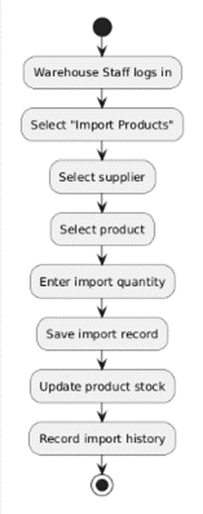
Figure ‎2.4-3: Import product diagram
The activity diagram illustrates the sequential workflow for the Inventory Import process executed by the Warehouse Staff. The process initiates when the staff member logs into the system and selects the "Import Products" function to begin a restocking transaction. The workflow requires the user to first identify the source of the goods by selecting a supplier, followed by choosing the specific product from the catalog that needs to be restocked.
After identifying the product, the user enters the import quantity. The system then performs a series of automated data operations: it first saves the import record to document the transaction details. Crucially, the system immediately updates the product stock level in the database to reflect the increased inventory. Finally, the system records the import history to ensure traceability and auditability of stock movements, marking the completion of the process.

Admin generate revenue report
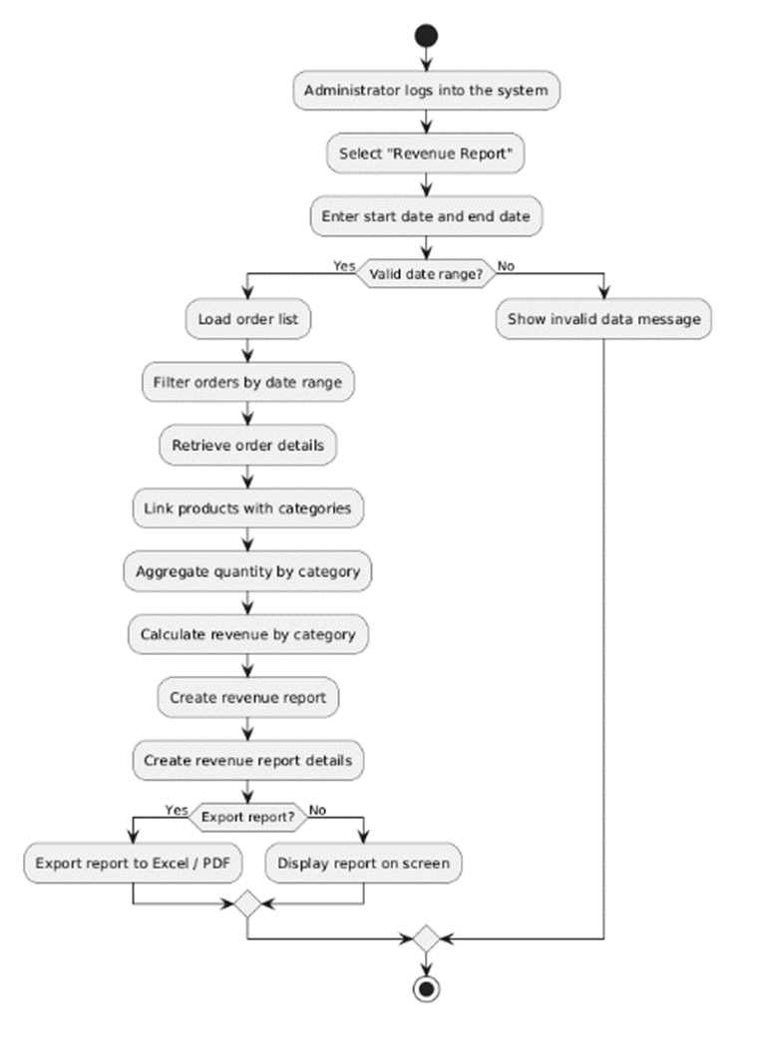
Figure ‎2.4-4: Generate revenue report diagram
The final activity diagram depicts the Revenue Reporting workflow, a critical analytical function executed by the Administrator. The process begins with the administrator logging into the system and navigating to the "Revenue Report" module. The user is then prompted to define the scope of the report by entering a specific start date and end date.
Upon submission, the system performs a validation check on the date range. If the input is invalid (e.g., the end date precedes the start date), the system displays an error message, and the process terminates. Conversely, if the date range is valid, the system initiates a complex data processing sequence: it loads the order list, filters records within the specified period, retrieves detailed order items, and links products with their respective categories.
Following data retrieval, the system aggregates the quantities sold by category and calculates the total revenue. The report and its detailed breakdown are then generated. At this stage, the administrator is presented with a decision to export the data. If confirmed, the system exports the report to an Excel or PDF file; otherwise, the report is simply displayed on the screen for immediate review.

Sequence diagram

Sales staff create order
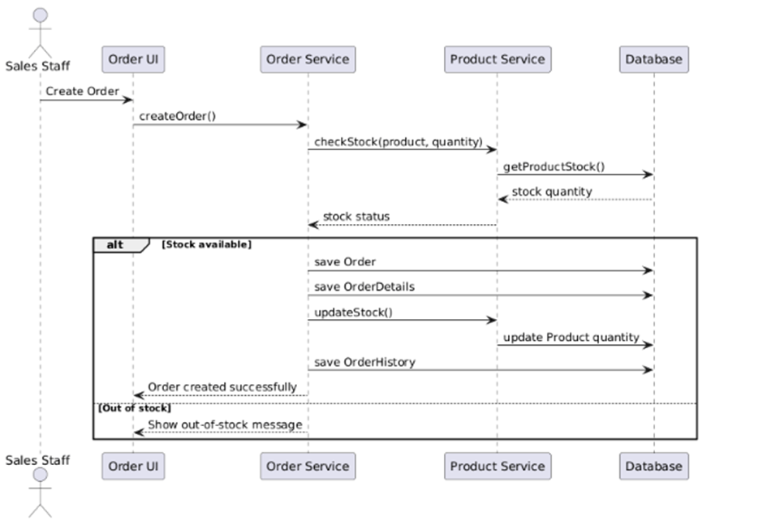
Figure ‎2.4-5: Create order diagram
The final sequence diagram illustrates the complex inter-component communication required to execute a "Create Order" transaction initiated by the Sales Staff. The workflow involves four primary lifelines: the Order UI, the Order Service (orchestrator), the Product Service (inventory logic), and the Database. The process begins when the Sales Staff submits a "Create Order" request via the UI, which invokes the createOrder() method on the Order Service. Before any data is persisted, the Order Service must validate inventory availability by calling checkStock() on the Product Service. This service, in turn, queries the Database using getProductStock() to retrieve the current stock quantity and returns the status to the Order Service.
The workflow then enters a conditional "Alternative" fragment (alt) based on the stock status. In the primary scenario (Stock available), the Order Service orchestrates a multi-step transaction: it sends commands to the Database to save Order and save OrderDetails. Simultaneously, it invokes updateStock() on the Product Service, which triggers a database update to deduct the sold quantity. Finally, the system logs the transaction via save OrderHistory and returns an "Order created successfully" message to the UI. In the alternative scenario (Out of stock), the process is terminated early, and the Order Service simply returns a signal to display an "out-of-stock message" to the user, preventing the creation of an invalid order.

Warehouse import products
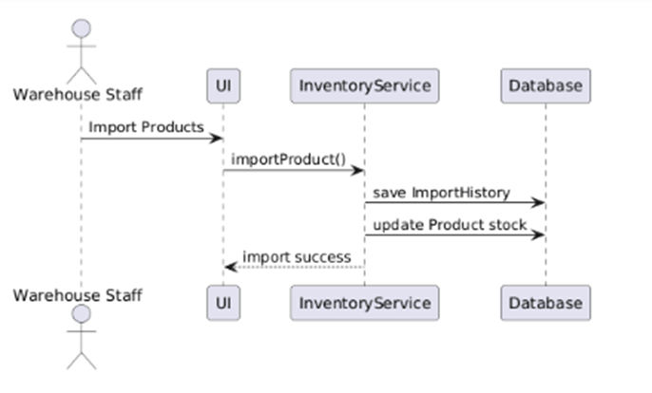
Figure ‎2.4-6: Import products diagram
The sequence diagram delineates the dynamic interactions between the system components during the inventory import process initiated by the Warehouse Staff. The interactions are modeled across three distinct lifelines: the User Interface (UI), the InventoryService (Business Logic Layer), and the Database (Data Layer). The sequence commences when the Warehouse Staff triggers the "Import Products" event via the UI. The UI layer then propagates this request by invoking the importProduct() method on the InventoryService.
Upon receiving the request, the InventoryService executes critical data persistence operations. It first sends a message to the Database to save ImportHistory, ensuring that the transaction is securely logged for audit purposes. Immediately following this, the service issues a command to update Product stock, reflecting the increased quantity in the system's records. Once these database transactions are successfully committed, the InventoryService returns a confirmation signal to the UI, which subsequently displays an "import success" notification to the Warehouse Staff, thereby concluding the synchronous operation.

Admin generate revenue report
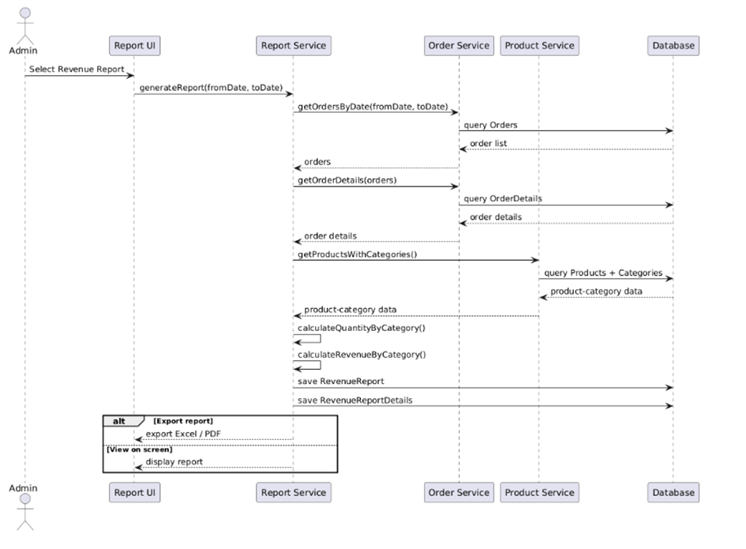
Figure ‎2.4-7: Generate revenue report diagram
The revenue reporting process involves a sophisticated orchestration of multiple services to aggregate data for the Administrator. As depicted in the sequence diagram, the workflow begins when the Admin triggers the "Select Revenue Report" event on the Report UI, which sends a generateReport() request containing the date range to the Report Service. To construct the report, the Report Service acts as a central aggregator, initiating a series of data retrieval calls. It first requests getOrdersByDate() and getOrderDetails() from the Order Service, which in turn executes queries against the Database to fetch the relevant transaction records. Simultaneously, the Report Service communicates with the Product Service via getProductsWithCategories() to obtain structural product data from the Database.
Once the raw data is aggregated, the Report Service performs internal processing by executing calculateQuantityByCategory() and calculateRevenueByCategory() to synthesize the analytical results. The generated report data is then persisted to the Database through save RevenueReport commands. Finally, the process concludes with a conditional alternative fragment (alt) regarding the output format. Depending on the user's selection, the system either returns an export Excel / PDF signal for file download or triggers a display report signal to render the data directly on the screen for immediate review.

TEST DESIGN & EXECUTION

Database design
The Online Sales Management System uses a relational database to store and manage operational data such as products, inventory movements, invoices, purchases, employees, attendance records, system configuration, and expenses. The schema is designed to support the system’s multi-role workflow (Admin, Sales Staff, Warehouse Staff) while ensuring data integrity, security, and maintainability.
From a security standpoint, the system leverages ASP.NET Core Identity for authentication and authorization, including user accounts, roles, claims, and tokens. In addition to standard role-based authorization, the design follows RBAC principles to keep permissions aligned with job functions and to support least-privilege access control (users only see and perform what their role/permission allows).
To ensure data quality, the schema applies standard relational constraints:
- Primary keys uniquely identify each entity.
- Foreign keys enforce referential integrity between related tables (for example, invoice headers and invoice items; product master data and stock movements). Foreign key constraints prevent inconsistent updates or deletions that would break relationships.
- Where applicable, unique constraints can be used for business identifiers (e.g., product codes, emails, phone numbers) to avoid duplicates.
The database is structured with normalization in mind to reduce redundancy and prevent common anomalies during insert/update/delete operations. This improves consistency and long-term maintainability.
To improve performance for frequent queries (search, filtering, reporting), indexing is applied to key lookup columns and foreign key columns. SQL Server indexes speed up row retrieval and are essential for responsive list pages (products, customers, invoices, purchases).

Authentication and authorization
Figure ‎3.1-1: Authentication and authorization erd
This diagram covers the identity and access-control layer. The core tables include AspNetUsers, AspNetRoles, and their linking tables (e.g., AspNetUserRoles, user claims/logins/tokens). These tables manage user authentication, role assignments, and authorization data used throughout the application. In the administration layer, the schema may extend Identity to support permission grouping (e.g., administrative groups and group-permission mapping) so that UI modules and actions can be enabled/disabled consistently based on assigned permissions.

Sales purchasing and inventory
Figure ‎3.1-2: Sales purchasing and inventory
This diagram represents the main business domain of the system:
- Product master data: Products are categorized by Categories, associated with Brands, and standardized by Units.
- Sales flow: Invoices store the invoice header (customer, date, totals, status), while InvoiceItems store line items (product, quantity, price).
- Purchasing flow: Purchases store goods receipt/purchase headers (supplier, date), while PurchaseItems store the purchased product lines.
- Inventory tracking: StockMovements record quantity changes per product (inbound from purchases, outbound from sales), forming the basis for stock-on-hand calculation and auditability.
This design follows the standard header-detail pattern (Invoice–InvoiceItems, Purchase–PurchaseItems) to ensure each transaction is stored consistently and can scale to multiple line items.

Human resources and attendance
Figure ‎3.1-3: Human resources and attendance erd
This diagram supports internal employee management and attendance tracking. Typical entities include Employees (employee profiles), reference tables such as Positions/Departments (depending on the implementation), and Attendance records that log daily check-in/check-out or attendance status. This module enables administrators to maintain staff records and supports operational reporting (e.g., attendance summaries by employee and date range).

System configuration and lookup
Figure ‎3.1-4: System configuration erd
This diagram stores configuration data used to standardize system behavior and UI defaults. Configuration tables (e.g., SystemSettings / AppSettings) centralize parameters such as company information, invoice rules, formatting options, thresholds (low-stock alert levels), and other configurable values. Keeping configuration in dedicated tables improves maintainability and reduces hard-coded values in the application.

Expense management
Figure ‎3.1-5: Expense management erd
This diagram captures operational expenses to support cost tracking and basic financial monitoring. It typically includes Expenses (expense records), optional categorization (e.g., ExpenseCategories), and related references (payment method, approval/created-by user, timestamps).
This module allows administrators to record and review expenses, supporting monthly summaries and management oversight.

Entity relationships and descriptions
Table ‎3.1-1: Entity relationships and descriptions
Table name | Key fields | Description | Relationships
AdminGroups | Id (PK), Name (Unique), Description, IsActive | Permission group | Referenced by AspNetUsers.AdminGroupId (SetNull). Referenced by GroupPermissions.AdminGroupId (Cascade)
GroupPermissions | Id (PK), AdminGroupId (FK), Module, Action (Unique: AdminGroupId+Module+Action) | Stores allowed actions per module for each AdminGroup (permission-based authorization) | FK AdminGroupId → AdminGroups.Id (Cascade)
AspNetUsers | Id (PK), UserName/NormalizedUserName (Unique), Email, FullName, IsActive, AdminGroupId (FK) | Identity users for authentication/authorization (customized Identity user). | FK AdminGroupId → AdminGroups.Id (SetNull). Referenced by AspNetUserClaims / AspNetUserLogins / AspNetUserRoles / AspNetUserTokens (Cascade)
AspNetRoles | Id (PK), Name, NormalizedName (Unique) | Identity roles. | Referenced by AspNetUserRoles.RoleId (Cascade), AspNetRoleClaims.RoleId (Cascade)
AspNetUserRoles | UserId (PK, FK), RoleId (PK, FK) | Many-to-many mapping between users and roles. | FK UserId → AspNetUsers.Id (Cascade). FK RoleId → AspNetRoles.Id (Cascade)
AspNetUserClaims | Id (PK), UserId (FK), ClaimType, ClaimValue | Stores claims for users. | FK UserId → AspNetUsers.Id (Cascade)
AspNetRoleClaims | Id (PK), RoleId (FK), ClaimType, ClaimValue | Stores claims for roles. | FK RoleId → AspNetRoles.Id (Cascade)
AspNetUserLogins | LoginProvider (PK), ProviderKey (PK), UserId (FK) | External login providers for Identity | FK UserId → AspNetUsers.Id (Cascade)
AspNetUserTokens | UserId (PK, FK), LoginProvider (PK), Name (PK), Value | Token storage for Identity | FK UserId → AspNetUsers.Id (Cascade)
Brands | Id (PK), Name, IsActive | Brand master data for products | Referenced by Products.BrandId (Restrict)
Categories | Id (PK), Name (Unique), Description, IsTrending, IsActive | Category master data for products; supports trending categories. | Referenced by Products.CategoryId (Restrict)
Units | Id (PK), Name (Unique), ShortName, IsActive | Unit of measurement (pcs, box, kg…). | Referenced by Products.UnitId (Restrict)
Products | Id (PK), SKU (Unique), Name, CategoryId (FK), UnitId (FK), BrandId (FK), CostPrice, SalePrice, StockOnHand, ReorderLevel, IsTrending, IsActive | Central product catalog + inventory attributes (stock/reorder). | FK CategoryId → Categories.Id (Restrict). FK UnitId → Units.Id (Restrict). FK BrandId → Brands.Id (Restrict). Referenced by InvoiceItems.ProductId (Restrict), PurchaseItems.ProductId (Restrict), StockMovements.ProductId (Cascade)
Customers | Id (PK), Name, Phone, Email, Address, IsActive, CreatedAt | Customer information for sales invoices | Referenced by Invoices.CustomerId (SetNull) so invoices remain even if customer is removed
Suppliers | Id (PK), Name, Phone, Email, Address, IsActive, CreatedAt | Supplier information for purchasing workflow | Referenced by Purchases.SupplierId (Restrict)

Website mockup
Based on the business analysis and system requirements presented in the previous chapter, we used Figma to develop a set of UI prototypes that model key user journeys for the main actors of the Online Sales Management System (e.g., Sales Staff, Warehouse, and Administrator). The prototypes define screen layouts, navigation, and interactive flows, enabling us to preview and validate how users interact with the system before implementation. Guided by a human-centred design approach, the interface was iteratively refined to improve usability, effectiveness, and efficiency, thereby supporting core tasks such as issuing sales invoices, managing inventory movements, and generating statistical reports accurately and conveniently

UI rules and conventions
The following UI rules and conventions were defined to ensure a consistent user experience across all modules and roles (Sales-Staff, Warehouse, and Admin). The objective is to reduce learning time, prevent operational mistakes, and make everyday tasks faster by standardizing layouts, components, feedback messages, and data presentation patterns. The interface design follows a human-centred approach and was refined iteratively based on clarity and usability considerations.

Login mockup

Figure ‎3.2-1: Login mockup
The Login Page is designed as a secure entry point to the system, featuring a modern dark-themed interface. Users are required to authenticate by entering their "Username or Email" and "Password" to access the management dashboard. Additionally, the screen includes "Remember me" and "Forgot Password" options to enhance user convenience while maintaining security.

Sales-Staff
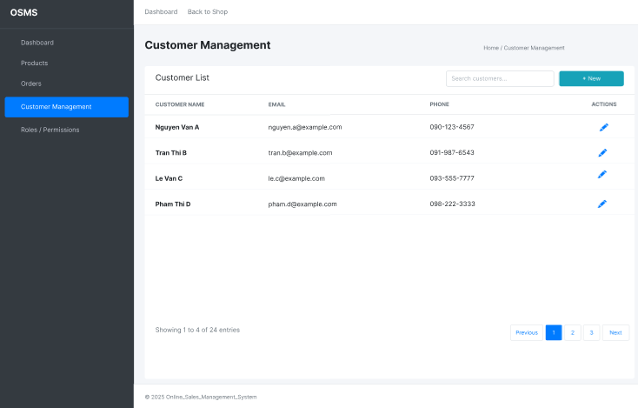
Figure ‎3.2-2: Sales staff - customer list mockup
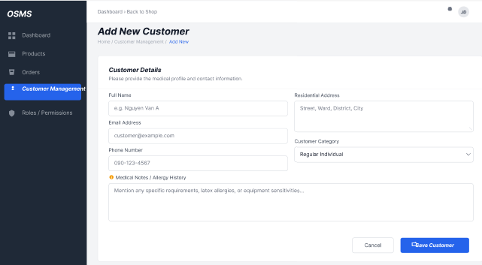
Figure ‎3.2-3: Sales staff - add new customer mockup
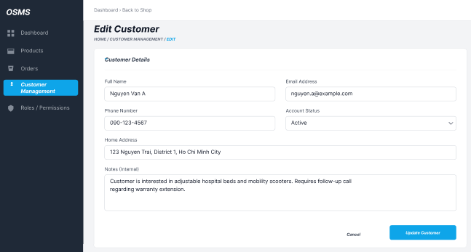
Figure ‎3.2-4: Sales staff - edit customer mockup
The Customer Management interface is designed to provide Sales Staff with advanced tools for maintaining a centralized and accurate client database. In this module, users can efficiently oversee the entire customer list, utilizing the search bar to quickly locate specific profiles based on names or phone numbers.
The system allows users to register new customers by inputting essential details such as Customer Name, Phone Number, Email, and Address. Furthermore, it supports the modification of existing records to ensure data stays current. This functionality guarantees absolute accuracy and consistency of customer information, which is a critical prerequisite for processing sales invoices and arranging deliveries effectively.

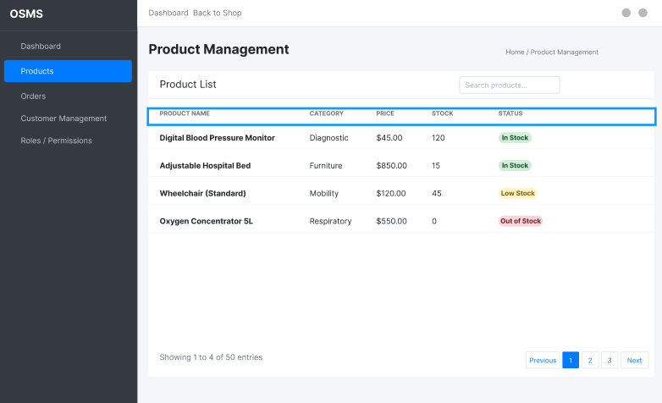
Figure ‎3.2-5: Sales staff – product list mockup
The Product Management interface is designed to provide Sales Staff with real-time visibility into the store's inventory. This module offers a centralized view where users can track essential product details, including Product Name, Category, Price, and Stock Quantity.
To support quick decision-making, the system features color-coded status indicators—such as "In Stock" (Green), "Low Stock" (Yellow), and "Out of Stock" (Red). This visual aid enables staff to instantly assess product availability, ensuring that sales consultations are accurate and helping to identify items that require replenishment immediately.
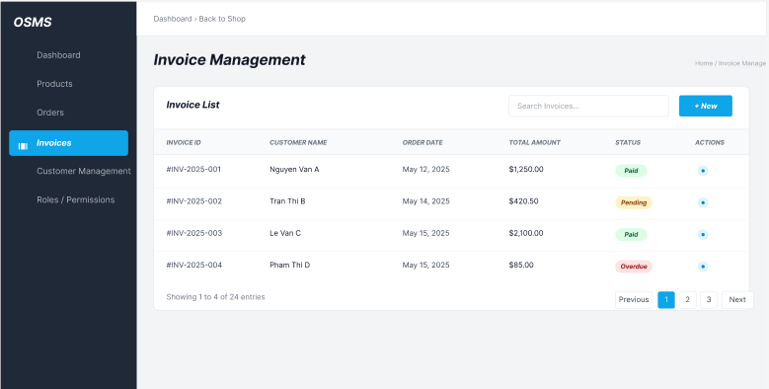
Figure ‎3.2-6: Sales staff - invoice list mockup
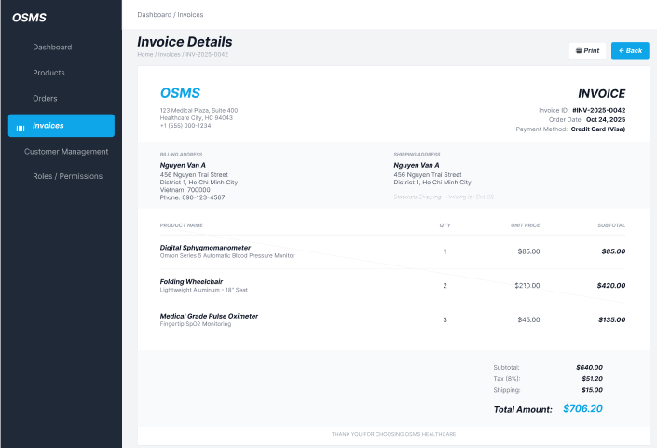
Figure ‎3.2-7: Sales staff - invoice details mockup
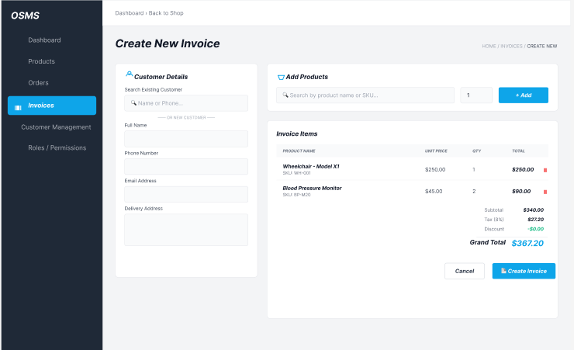
Figure ‎3.2-8: Sales staff - create new invoice mockup
The Invoice Management interface serves as the central financial processing hub for Sales Staff, enabling efficient handling of all sales transactions. The main dashboard presents a comprehensive Invoice List, displaying critical data such as Invoice ID, Customer Name, Date, Total Amount, and Payment Status (e.g., Paid or Unpaid). This overview allows staff to quickly track revenue and monitor outstanding payments.
To facilitate daily operations, the system includes a "Create New Invoice" feature, where users can select a customer and add multiple products to the bill. The interface automatically calculates the Subtotal, Tax, and Grand Total in real-time. Additionally, the Invoice Details view provides a granular breakdown of each completed transaction, ensuring financial accuracy and transparency before the final invoice is issued to the client.

Warehouse
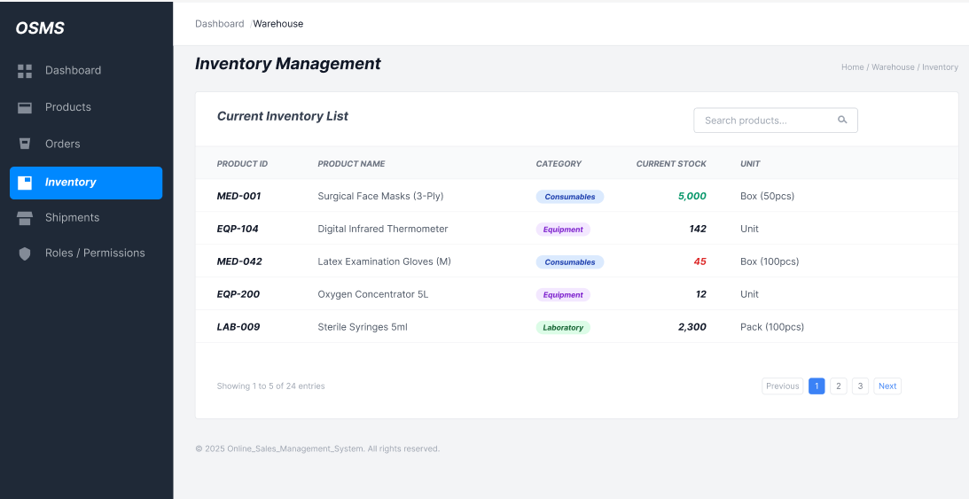
Figure ‎3.2-9: Warehouse – inventory list mockup
The Inventory Management interface is specifically designed for Warehouse Staff to maintain precise control over stock levels. The central feature is the "Current Inventory List", which provides a detailed breakdown of all available items, organized by Product ID, Product Name, and Category (e.g., Consumables or Equipment).
To enhance operational efficiency, the system displays the Current Stock with visual indicators—using Green for high availability (e.g., 5,000 units) and Red to alert staff of low stock levels (e.g., 45 units). This clear visualization allows warehouse personnel to instantly identify shortages and plan for replenishment, ensuring that the supply chain remains uninterrupted.
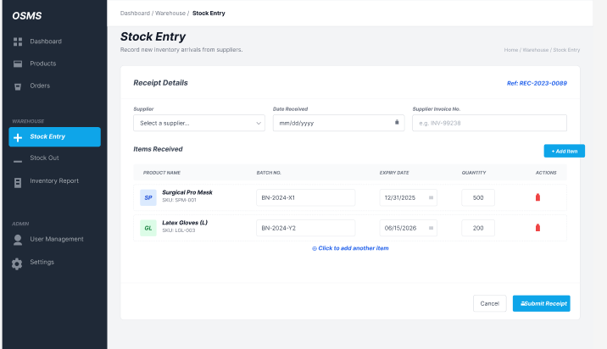
Figure ‎3.2-10: Warehouse – stock entry mockup
The Stock Entry interface is a critical module for Warehouse Staff to record new inventory arrivals effectively. The screen is designed with a clear "Receipt Details" section, requiring users to input essential procurement data such as the Supplier name, Date Received, and the external Supplier Invoice No. for cross-referencing.
To ensure detailed inventory tracking, the "Items Received" table allows users to add multiple products dynamically. For each item, the system mandates specific entries including Batch No. and Expiry Date—crucial for managing perishable goods like medical supplies. Once the quantities are verified, the user clicks "Submit Receipt" to finalize the entry, automatically updating the system's stock levels.

Admin

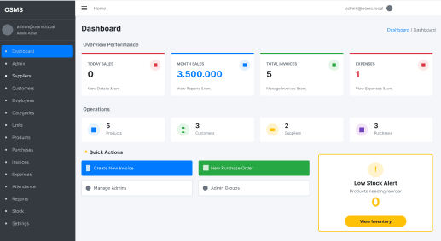
Figure ‎3.2-11: Admin - dashboard mockup
The System Dashboard serves as the central command center for the Administrator, offering a comprehensive snapshot of the business's health. The interface is structured with a high-level "Overview Performance" section, displaying real-time financial metrics including Today Sales, Month Sales (e.g., 3,500,000 VND), Total Invoices, and Expenses.
To facilitate rapid management, the dashboard features an "Operations" summary that counts active Products, Customers, and Suppliers. Furthermore, the "Quick Actions" panel provides one-click shortcuts for frequent tasks such as "Create New Invoice" (Blue button) and "New Purchase Order" (Green button). Notably, a dedicated "Low Stock Alert" widget is prominent on the screen, automatically warning the Admin about products needing immediate reordering to prevent stockouts.

Admin module mockups

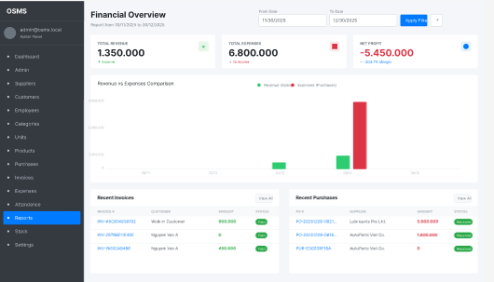
Figure ‎3.2-12: Admin – financial overview report mockup
The Financial Overview interface is a powerful analytical tool designed for the Administrator to monitor the system's economic performance. The dashboard features a flexible Date Range Filter (From Date - To Date), allowing users to generate specific reports for any given period.
The core of the screen displays three critical financial indicators: Total Revenue (Green), Total Expenses (Red), and Net Profit, providing an instant assessment of profitability. To visualize trends, a "Revenue vs Expenses Comparison" bar chart contrasts income against spending. Additionally, the bottom section lists "Recent Invoices" and "Recent Purchases" side-by-side, enabling the Admin to audit individual transactions and track cash flow details effectively.
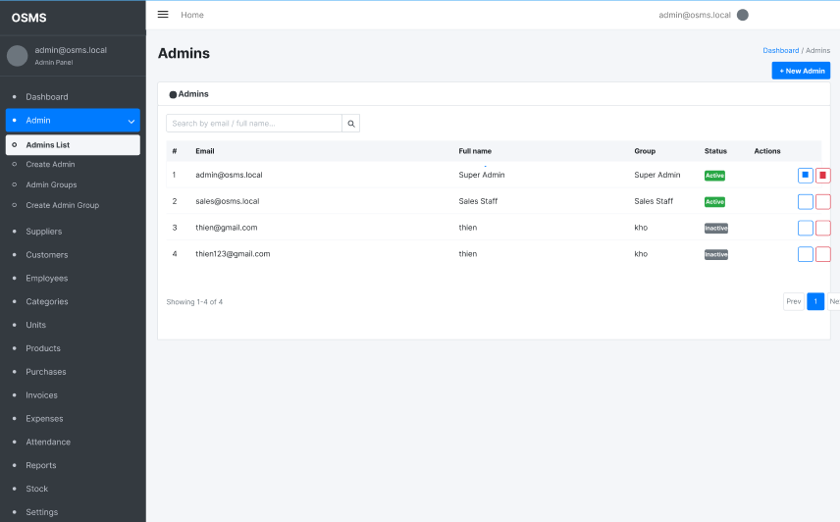
Figure ‎3.2-13: Admin – user account management mockup
The User Management interface is a critical security module that allows the Super Admin to control system access. The central view is the "Admins List", which functions as a centralized registry of all authorized personnel. The table provides a clear overview of user identities, displaying columns for Email, Full Name, and Group (Role).
A key feature of this interface is Role-Based access control (RBAC), visually distinguished in the "Group" column (e.g., super admin, sales staff, or warehouse staff). Additionally, the system enables account monitoring through "Status" badges—using Green for Active users and grey for Inactive accounts. Administrators can easily manage this list using the search bar to find specific emails or utilize the action buttons (edit/delete) to modify or revoke access rights as needed.
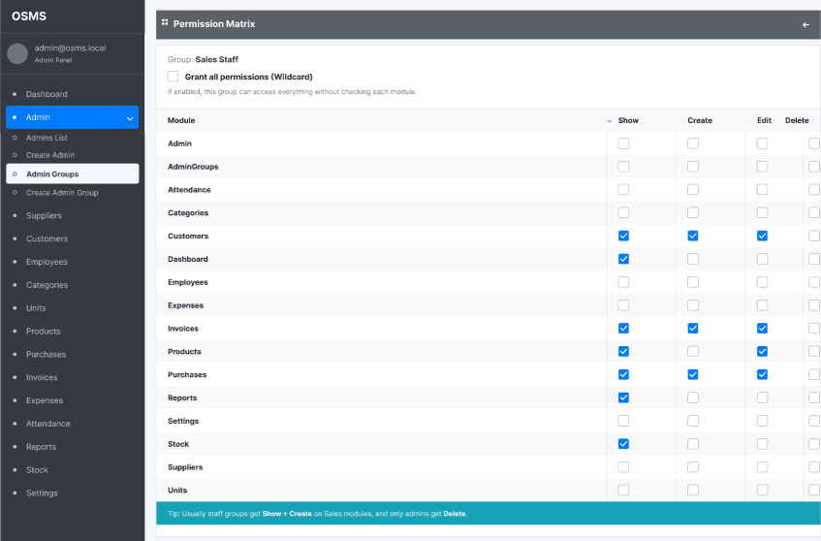
Figure ‎3.2-14: Admin - group permission matrix mockup
The Permission Matrix interface is an advanced security feature that grants the Administrator granular control over system access. In this view, the Admin can configure specific privileges for user groups, such as the "Sales Staff" role shown in the example.
The interface presents a detailed grid listing all system Modules (e.g., Customers, Invoices, Products) against four core actions: Show, Create, Edit, and Delete. This structure allows for precise customization; for instance, Sales Staff are granted "Show" and "Create" rights for Invoices and Customers to perform their duties but are restricted from the "Delete" action to prevent data loss. This implementation adheres to the principle of least privilege, ensuring that employees only access functions necessary for their specific roles.
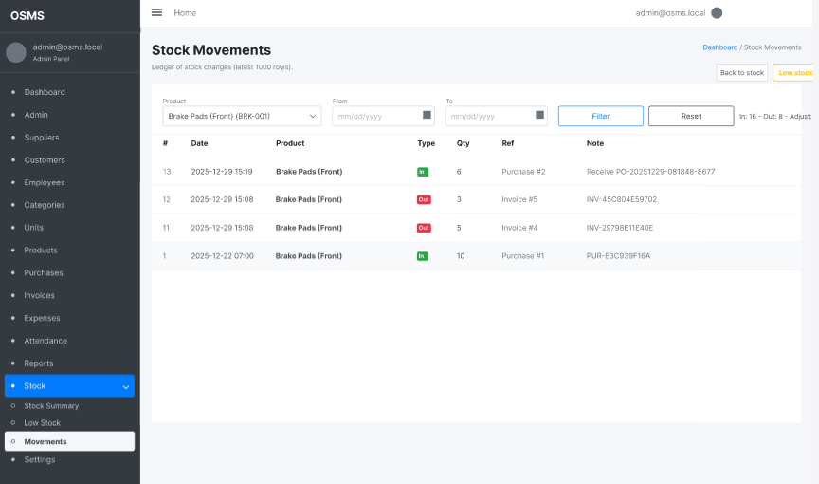
Figure ‎3.2-15: Admin - stock movements mockup
The Stock Movements interface serves as a detailed audit ledger for the Administrator and Warehouse Staff to track every inventory change. The screen features powerful Filtering Tools at the top, allowing users to search history by specific Product (e.g., Brake Pads) or within a defined Date Range.
The data table is designed for high visibility, utilizing color-coded "Type" badges: Green "In" tags represent stock additions (Purchases), while Red "Out" tags indicate stock deductions (Sales/Invoices). Furthermore, each transaction includes a "Ref" (Reference) column linking directly to the source document (e.g., Invoice #5 or Purchase #2), ensuring complete traceability and accountability for all goods moving through the warehouse.

System architecture
The Online Sales Management System is developed based on the three-layer MVC (Model–View–Controller) architectural model using the ASP.NET Core platform, ensuring a clear separation between the user interface, business logic, and data access layers. This separation enhances maintainability, scalability, and future extensibility of the application.
The project’s directory structure is organized systematically in compliance with technical standards: the Models folder contains entity classes representing products, customers, and inventory records directly mapped to the SQL Server database via Entity Framework Core; the Views folder manages the management dashboards and data forms that interact with end users; and the Controllers folder serves as the central layer responsible for handling HTTP requests from the client side.
In addition, the system architecture integrates essential configuration components such as appsettings.json for managing connection strings and Program.cs for setting up dependency injection services, ensuring stable performance and robust security within the web environment.

DETECT REPORT & METRICS

Development environment and tools
To ensure the stability and reliability of the Online Sales Management System, the development and testing phases were conducted within a standardized technical environment.
The system was developed primarily on the Windows operating system (64-bit architecture), utilizing the .NET 8.0 SDK as the core runtime environment.
For the integrated development environment, Microsoft Visual Studio 2022 was selected due to its robust support for C# debugging and intelligent code completion.
Database administration and query execution were managed using SQL Server Management Studio (SSMS), allowing for direct manipulation of the SQL Server database.
Furthermore, Git and GitHub were used extensively for version control, enabling the team to track source code changes and collaborate effectively.
Finally, the user interface design and system modeling were supported by Figma for wireframing and external UML tools for architectural diagramming.

Step-by-Step installation guide
To successfully deploy and execute the Online Sales Management System on a local machine, the following installation procedure must be strictly followed .

System preparation and source code retrieval
First, ensure that the development environment is fully prepared with Microsoft Visual Studio 2022 and Microsoft SQL Server installed.
Next, launch Visual Studio 2022 and select the "Clone a repository" option from the startup window.
Then, enter the URL of the project's GitHub repository into the provided field and click "Clone" to download the source code to the local machine.
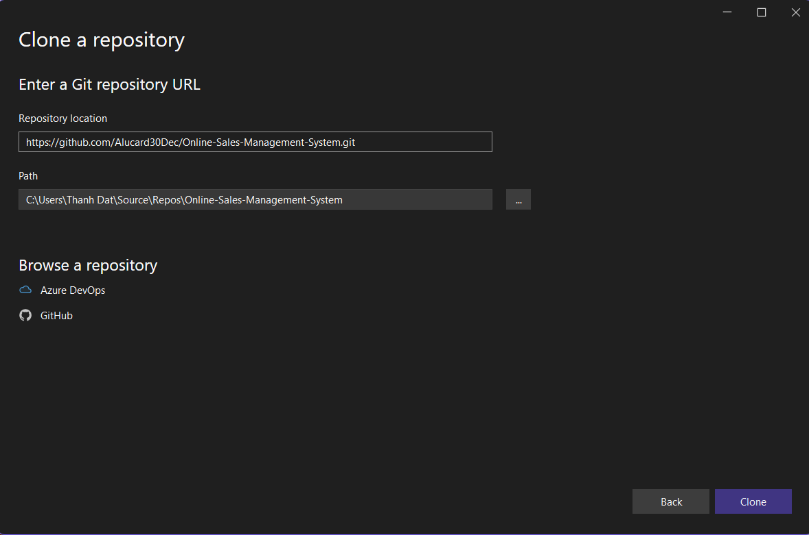
Figure ‎4.2-1: Cloning the project repository in visual studio
Once the cloning process is complete, the solution file (.sln) will open automatically. The Solution Explorer window will display the project's hierarchical structure, including critical directories such as Areas, Controllers, Services, and Views, confirming that the source code has been loaded successfully.
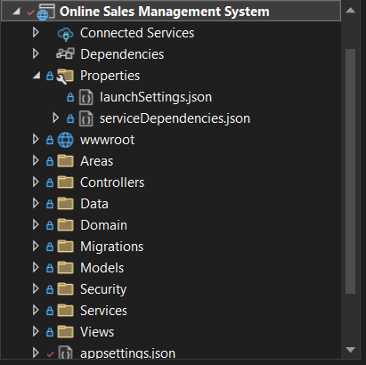
Figure ‎4.2-2: Project structure in solution explorer

Database configuration
To establish a connection between the application and the local database, the configuration file must be updated to reflect the host environment.
Open the appsettings.json file located in the root directory of the project.
Locate the ConnectionStrings section and modify the "DefaultConnection" value to match the server name of your local SQL Server instance (e.g., Server=THDAT).
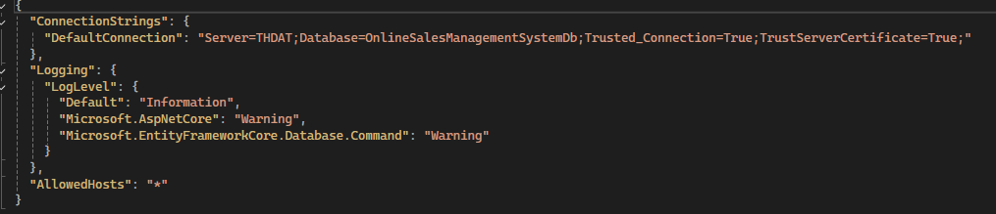
Figure ‎4.2-3: Connection string configuration in appsettings.json

Database initialization using migrations
Since the project utilizes the Entity Framework Core Code-First approach, the database schema must be generated from the C# models.
Navigate to the "Tools" menu, select "NuGet Package Manager", and click on "Package Manager Console".
In the console window, execute the command Update-Database to apply the migrations and create the database tables.
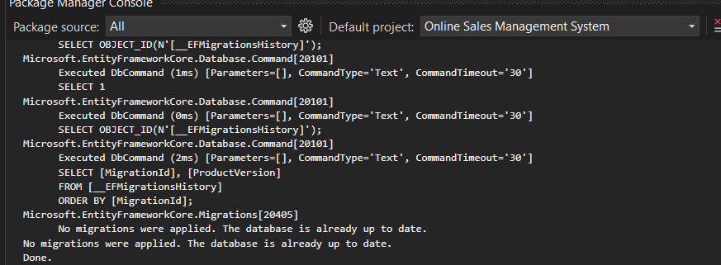
Figure ‎4.2-4: Applying migrations via package manager console
Upon successful execution, the console will display a "Done" message, indicating that the database named "OnlineSalesDB" has been created (or updated) in SQL Server Management Studio.

Running the application
Finally, to launch the application, press the green "Run" button (or press the F5 key) located in the Visual Studio toolbar.
The system will compile the latest build, start the local web server (IIS Express), and automatically open the default web browser.
The application will navigate to the Login Page, indicating that the server is running correctly and ready to accept user credentials.

Figure ‎4.2-5: Application login interface
Users can now log in using the administrator account (seeded in the database during migration) to verify the access rights.
Upon successful authentication, the system redirects the user to the Admin Dashboard, where they can begin managing sales, inventory, and reports.
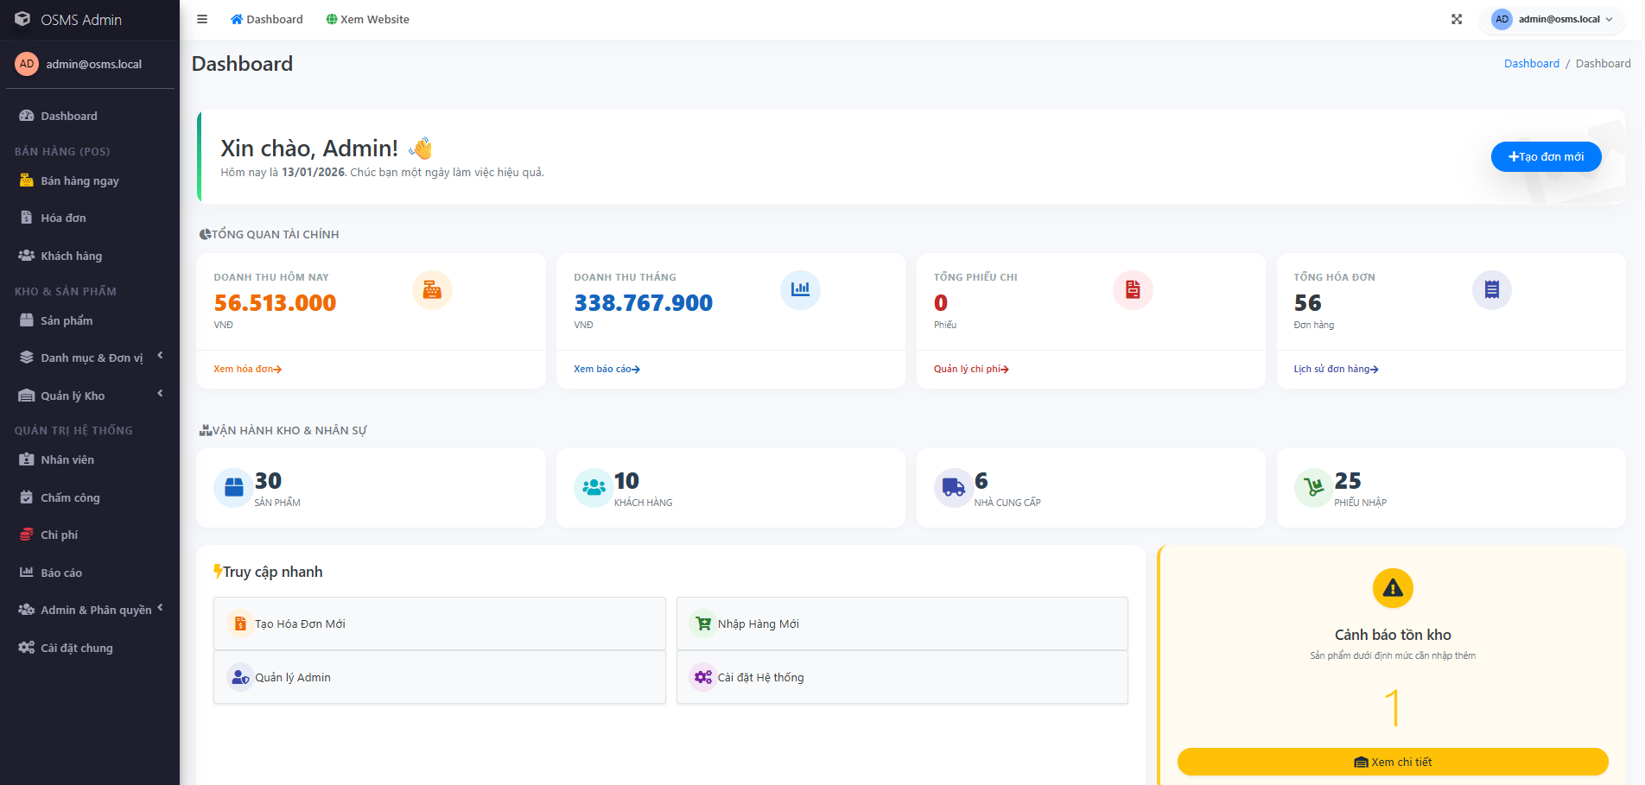
Figure ‎4.2-6: Administrator dashboard overview

Key code snippets and explanation
Among the various technical implementations in the system, the Dynamic Role-Based Access Control (RBAC) module stands out as a critical component. Unlike simple systems that use static roles , this system allows the Super Administrator to grant or revoke specific permissions (Show, Create, Edit, Delete, Approve, Export) for every distinct module dynamically.
Below are the key code snippets demonstrating how this complex logic is handled on both the server-side and the client-side interface.

Backend permission handling in controller layer
The core logic for assigning permissions is encapsulated within the AdminGroupsController. Specifically, the Permissions (POST) method is responsible for translating the user's selection from the UI into database records. The code employs a transactional strategy: it first removes existing permissions for the group and then inserts the new set of selected rights. This approach ensures that the database always reflects the exact state of the UI configuration.
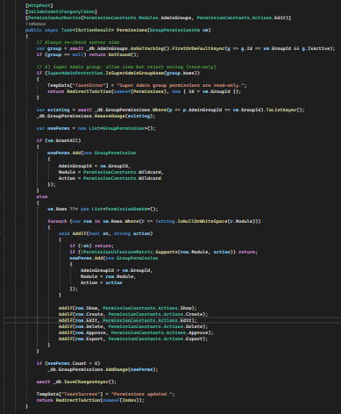
Figure ‎4.3-1: Controller layer code
Explanation: This snippet demonstrates high-level security coding practices. It includes the [PermissionAuthorize] attribute to protect the endpoint itself, checks for critical roles (Super Admin protection) to prevent system lockouts, and efficiently handles batch database updates using Entity Framework Core.

Dynamic permission matrix in presentation layer
To provide an intuitive user experience, the permission interface is rendered as a matrix table. The Razor View (Permissions.cshtml) dynamically generates rows for each system module. It utilizes nested loops and HTML helpers to bind the checkboxes directly to the View Model, allowing the data to be posted back to the server seamlessly.
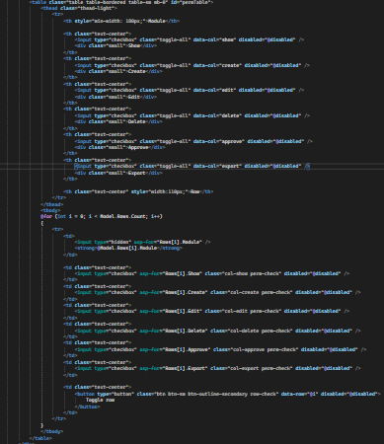
Figure ‎4.3-2: Presentation layer code
Explanation: This frontend code showcases the integration between C# Razor syntax and HTML. It creates a user-friendly grid where administrators can visualize and toggle permissions effectively. The corresponding visual result of this code is displayed in Figure 4.7 below.
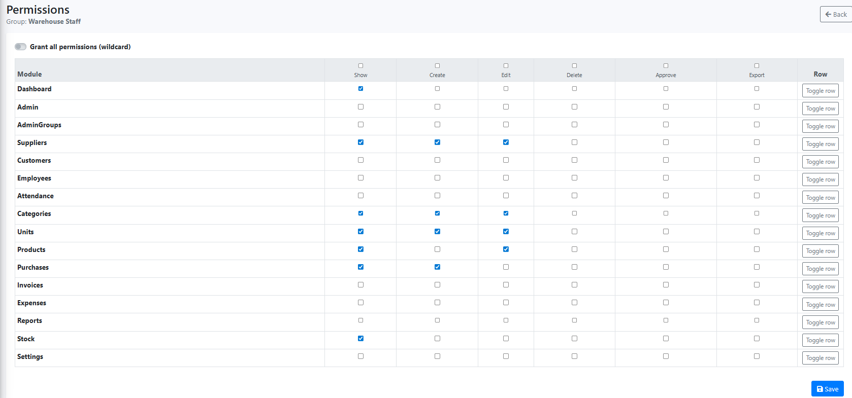
Figure ‎4.3-3: Dynamic group permissions matrix interface

Detailed processing workflow
Although the User Interface shown in Figure 4.7 appears simple, the backend processing logic ensures strict data integrity. When the administrator clicks the "Save" button, the Permissions (POST) method executes a strict workflow to update the database. First, the system validates that the target GroupId exists and is currently active, ensuring permissions are only assigned to valid operational groups. Next, a hard-coded security safeguard prevents modifications to the "Super Admin" group to avoid accidental system lockouts. To handle permission updates efficiently, the system employs a "clean and rebuild" strategy by removing all existing permissions for the group before applying the new configuration. After clearing old data, the system iterates through the matrix received from the View Model to calculate new permissions. If the "Grant All" option is selected, a wildcard permission is assigned; otherwise, the system verifies every selected action against the feature matrix to ensure compatibility. Finally, the new permission set is committed to the database atomically using SaveChangesAsync(), ensuring that either all permissions are saved successfully or none are.

Security enforcement mechanism
Defining permissions is only half of the solution; enforcing them is the critical final step. The system utilizes a custom attribute, [PermissionAuthorize], to protect sensitive resources. Whenever a user attempts to access a protected URL, such as editing supplier details, this attribute intercepts the request before it reaches the Controller. It immediately checks the user's current session permissions against the required Module and Action defined in the code. If the corresponding permission record is missing in the database, the request is immediately denied with a 403 Forbidden response. This ensures that the visual matrix directly controls the backend security in real-time.

Conclusion of RBAC implementation
In summary, the integration of the dynamic permission matrix combined with the attribute-based authorization provides a robust security framework. Unlike legacy systems that depend on hard-coded roles, this solution offers granular control, ensuring that users operate strictly within their assigned boundaries. This architecture minimizes the risk of unauthorized data manipulation and ensures that the system strictly adheres to the principle of least privilege.

Verification and testing results
To validate the reliability of the permission system, a comprehensive testing scenario was conducted using a test account belonging to the "Warehouse Staff" group. In the first test case, the "Edit" permission for the "Suppliers" module was revoked via the admin matrix interface shown in Figure 4.7. When the test user attempted to access the edit URL directly or clicked the edit button, the system's middleware successfully intercepted the request. Instead of loading the sensitive data form, the application redirected the user to a standardized "403 Access Denied" error page. This confirms that the frontend configuration successfully controls backend accessibility in real-time.
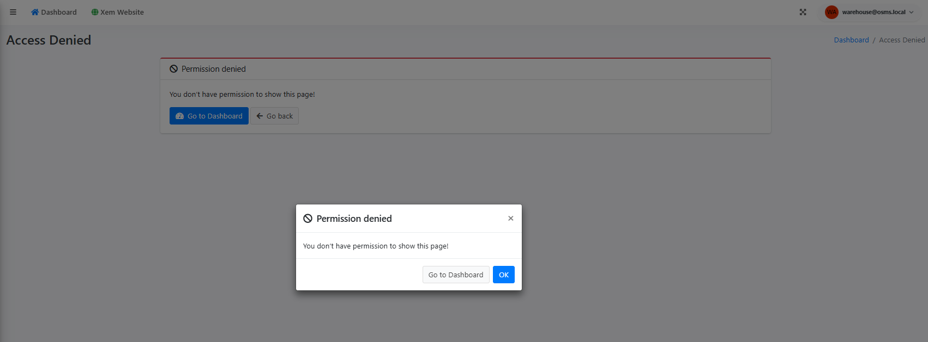
Figure ‎4.3-4: Access denied message

Screenshots of main features

Authentication and authorization

Login page

Figure ‎4.4-1: Login screen
The system login page where internal users enter their credentials to access the application.

Login success and redirect
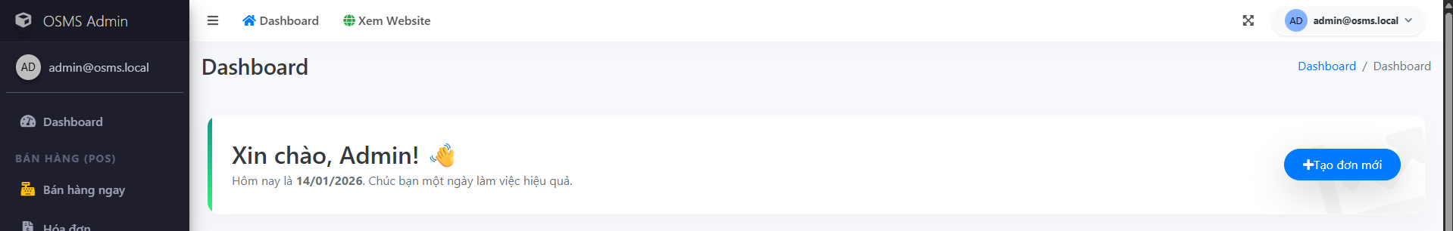
Figure ‎4.4-2: Successful login and role-based landing page
After a valid login, the system redirects the user to the correct home page based on their assigned role (Admin, Sales Staff, or Warehouse).

Authorization check and access denied
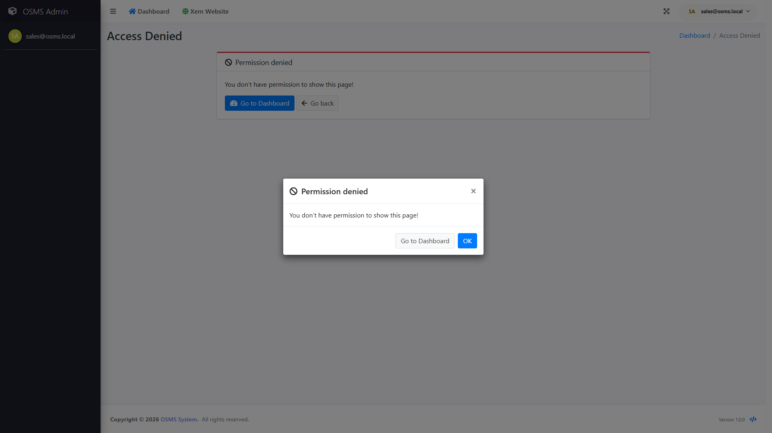
Figure ‎4.4-3: Access denied when permission is missing
Demonstrates RBAC enforcement: when a user opens a page without the required permission, the system blocks the request and shows an access denied message.

Admin main features

Admin dashboard
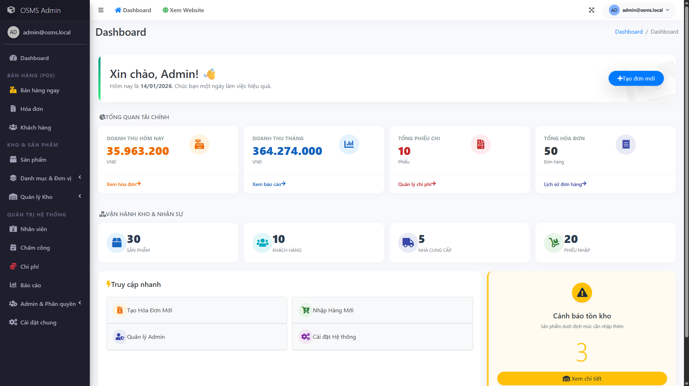
Figure ‎4.4-4: Admin dashboard
Provides a high-level view of system activity and key business indicators, helping administrators monitor overall operations at a glance.

User management
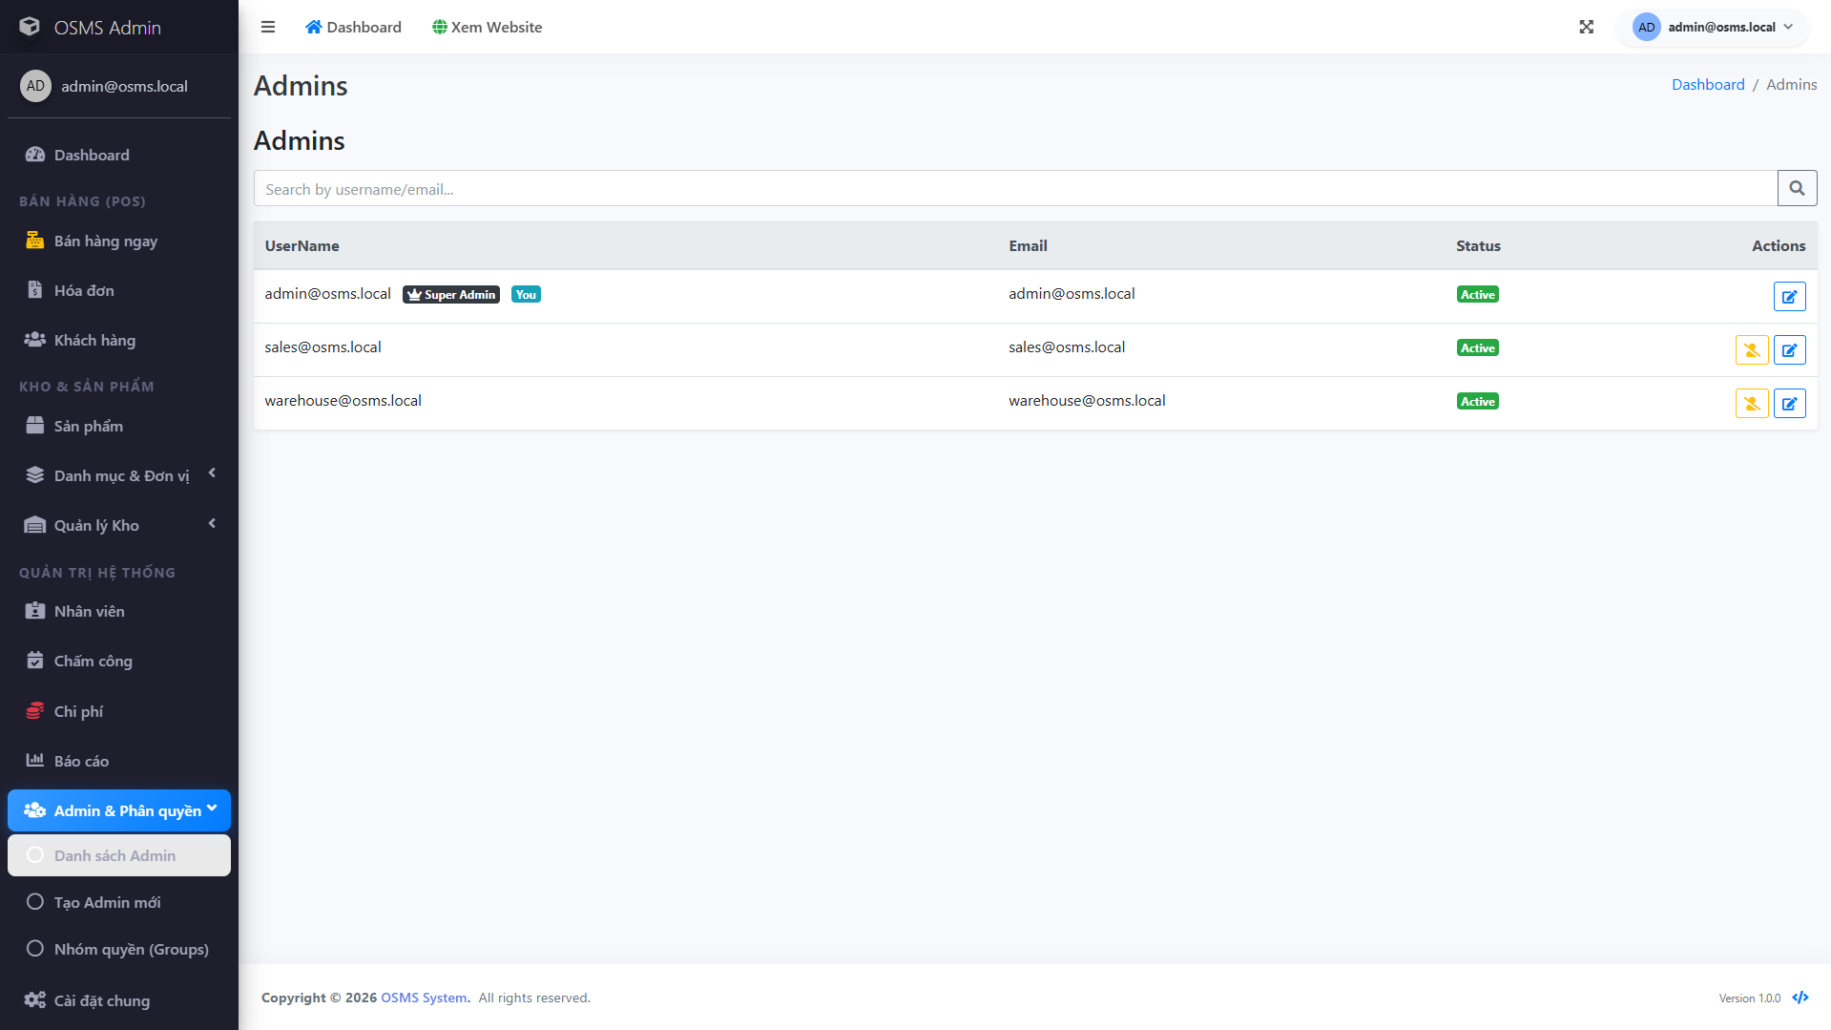
Figure ‎4.4-5: User management
Lists system accounts and supports common actions such as searching users, viewing details, and maintaining access status for staff accounts.

Role management
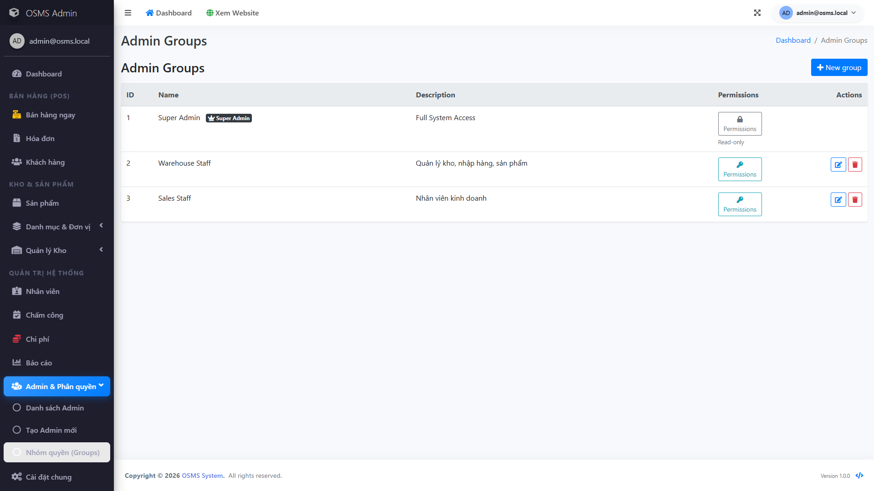
Figure ‎4.4-6: Role management
Shows how administrators manage roles/groups used by the RBAC model, including creating or updating role definitions.

Permission matrix or access control settings
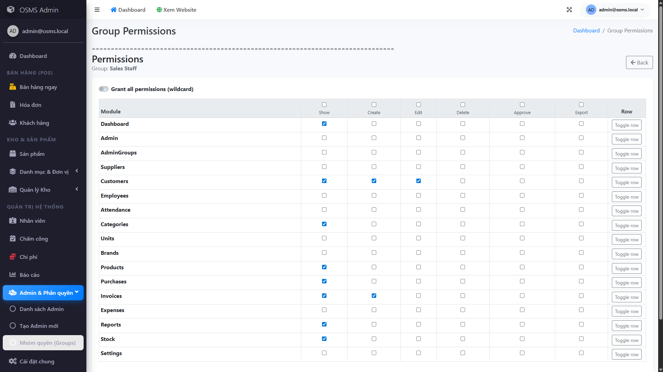
Figure ‎4.4-7: Permission matrix configuration
Displays the permission matrix where admins grant or revoke module-level actions per role to control what each group can access.

Employee management
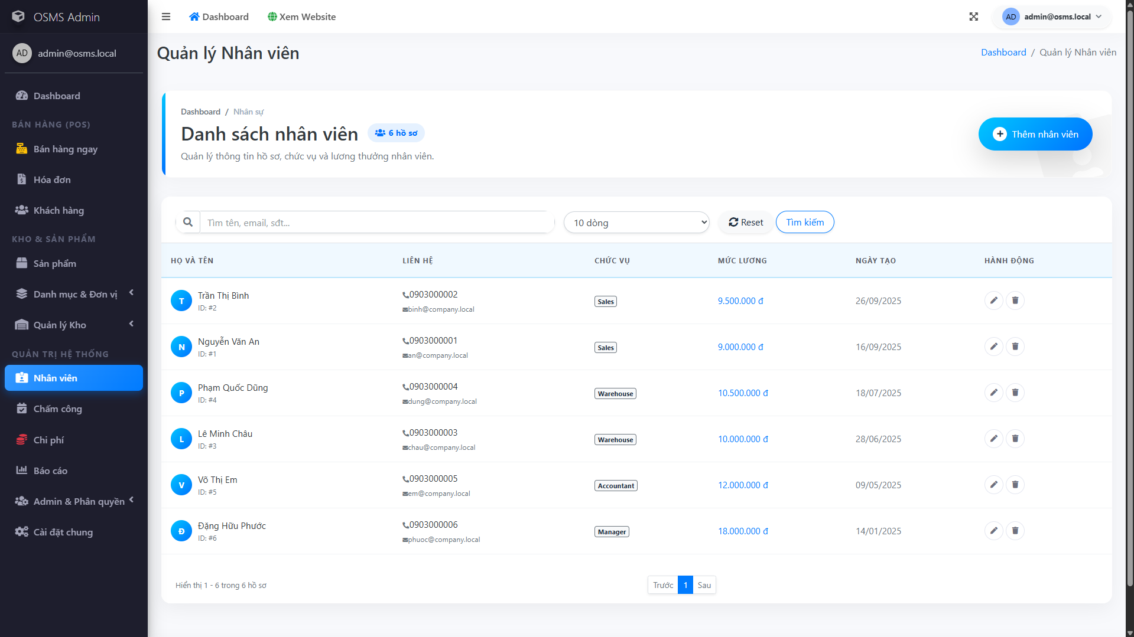
Figure ‎4.4-8: Employee management
Manages employee profiles used internally (for example, staff information and position), supporting day-to-day HR administration.

Attendance tracking
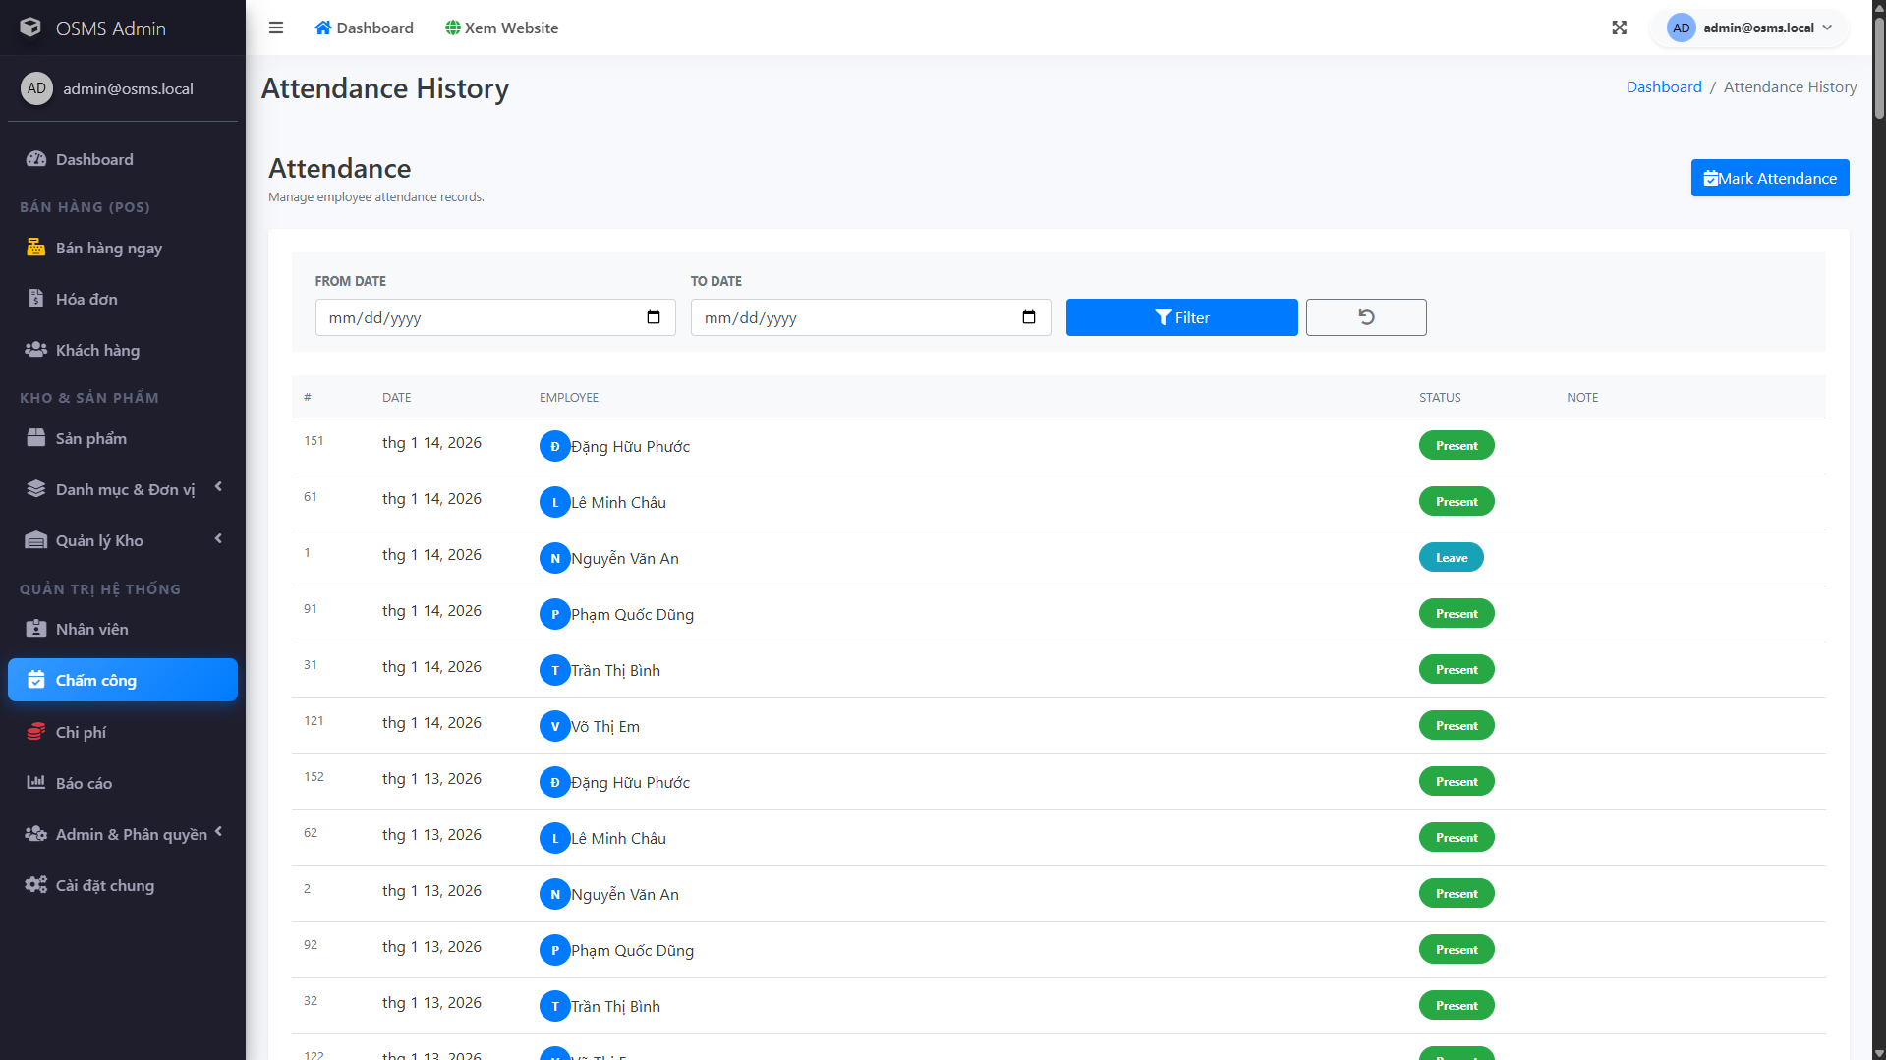
Figure ‎4.4-9: Attendance tracking
Shows attendance history and tracking tools, allowing admins to review records by date range and confirm attendance status.

Expense management
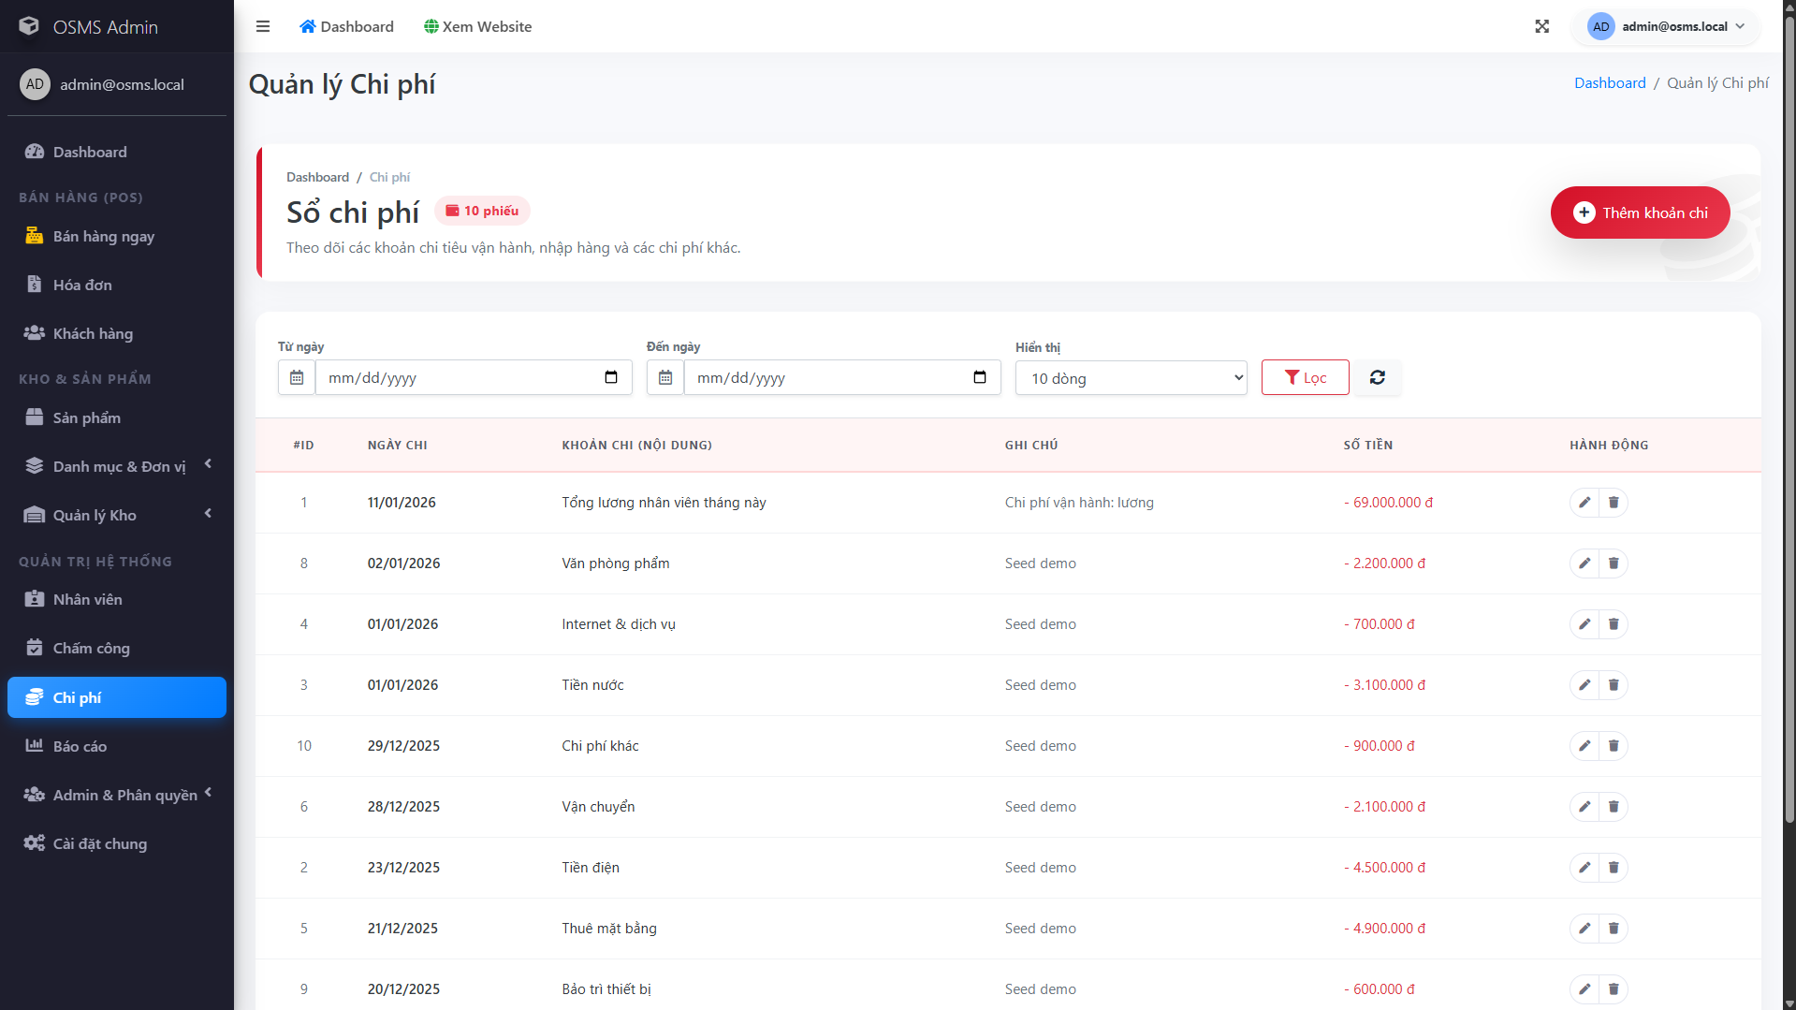
Figure ‎4.4-10: Expense management
Records operational expenses with filtering and quick review, supporting cost tracking that feeds into reporting and business analysis.
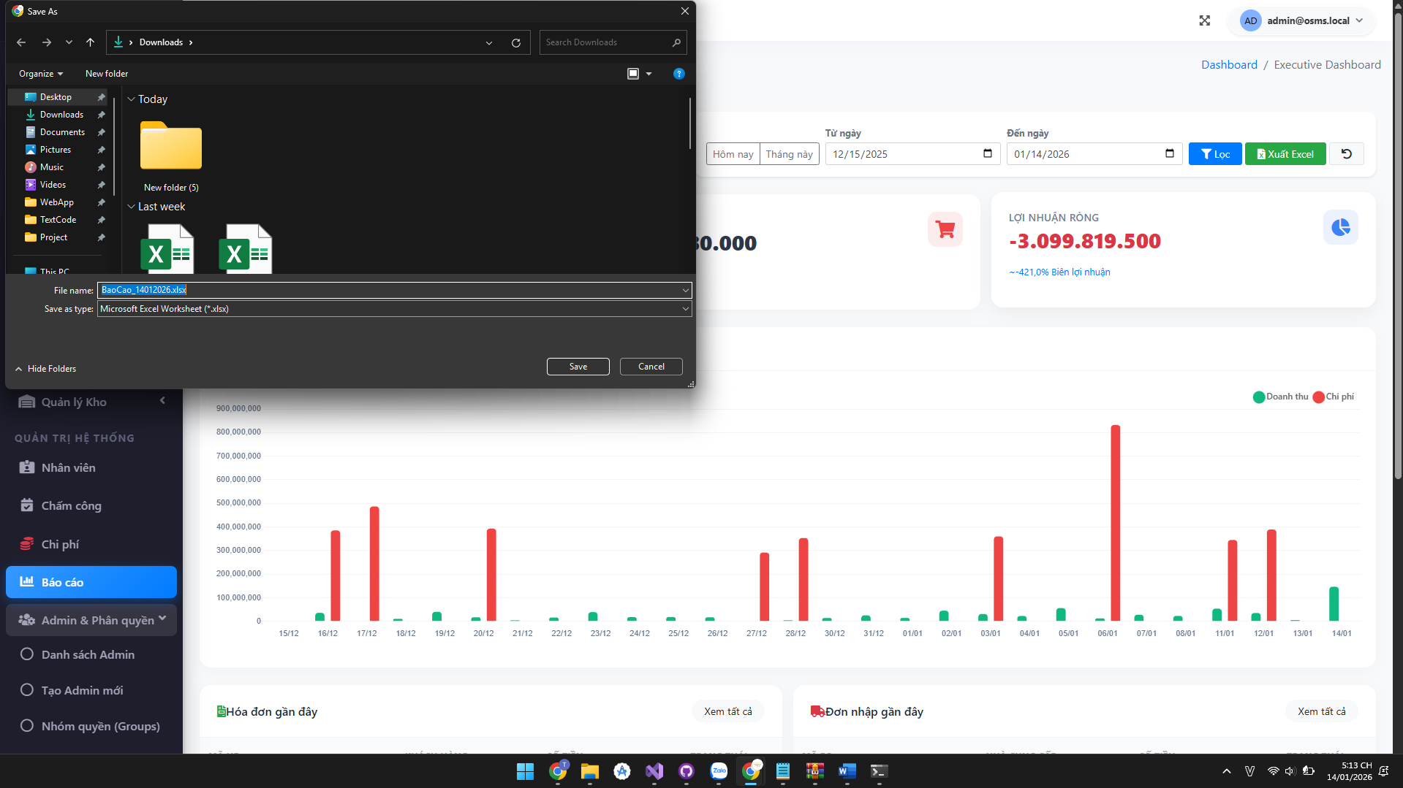
Figure ‎4.4-11: Executive reporting dashboard
Summarizes financial performance with charts and totals, giving administrators a clear overview of revenue, expenses, and profit trends.

Export reports to Excel
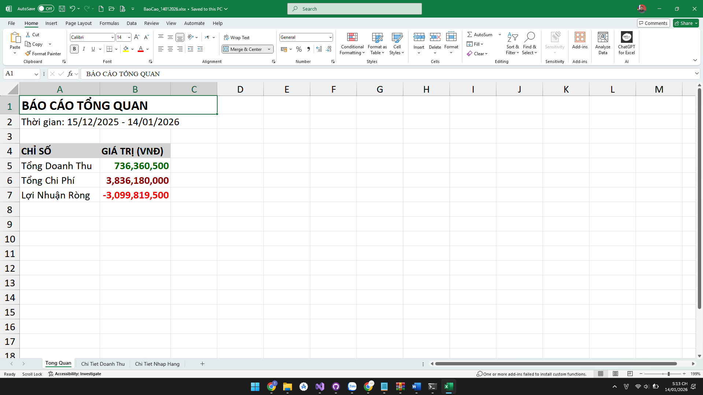
Figure ‎4.4-12: Exported Excel report
Example of an exported report opened in Excel, confirming that the system can generate downloadable summaries for offline review and sharing.

System configuration
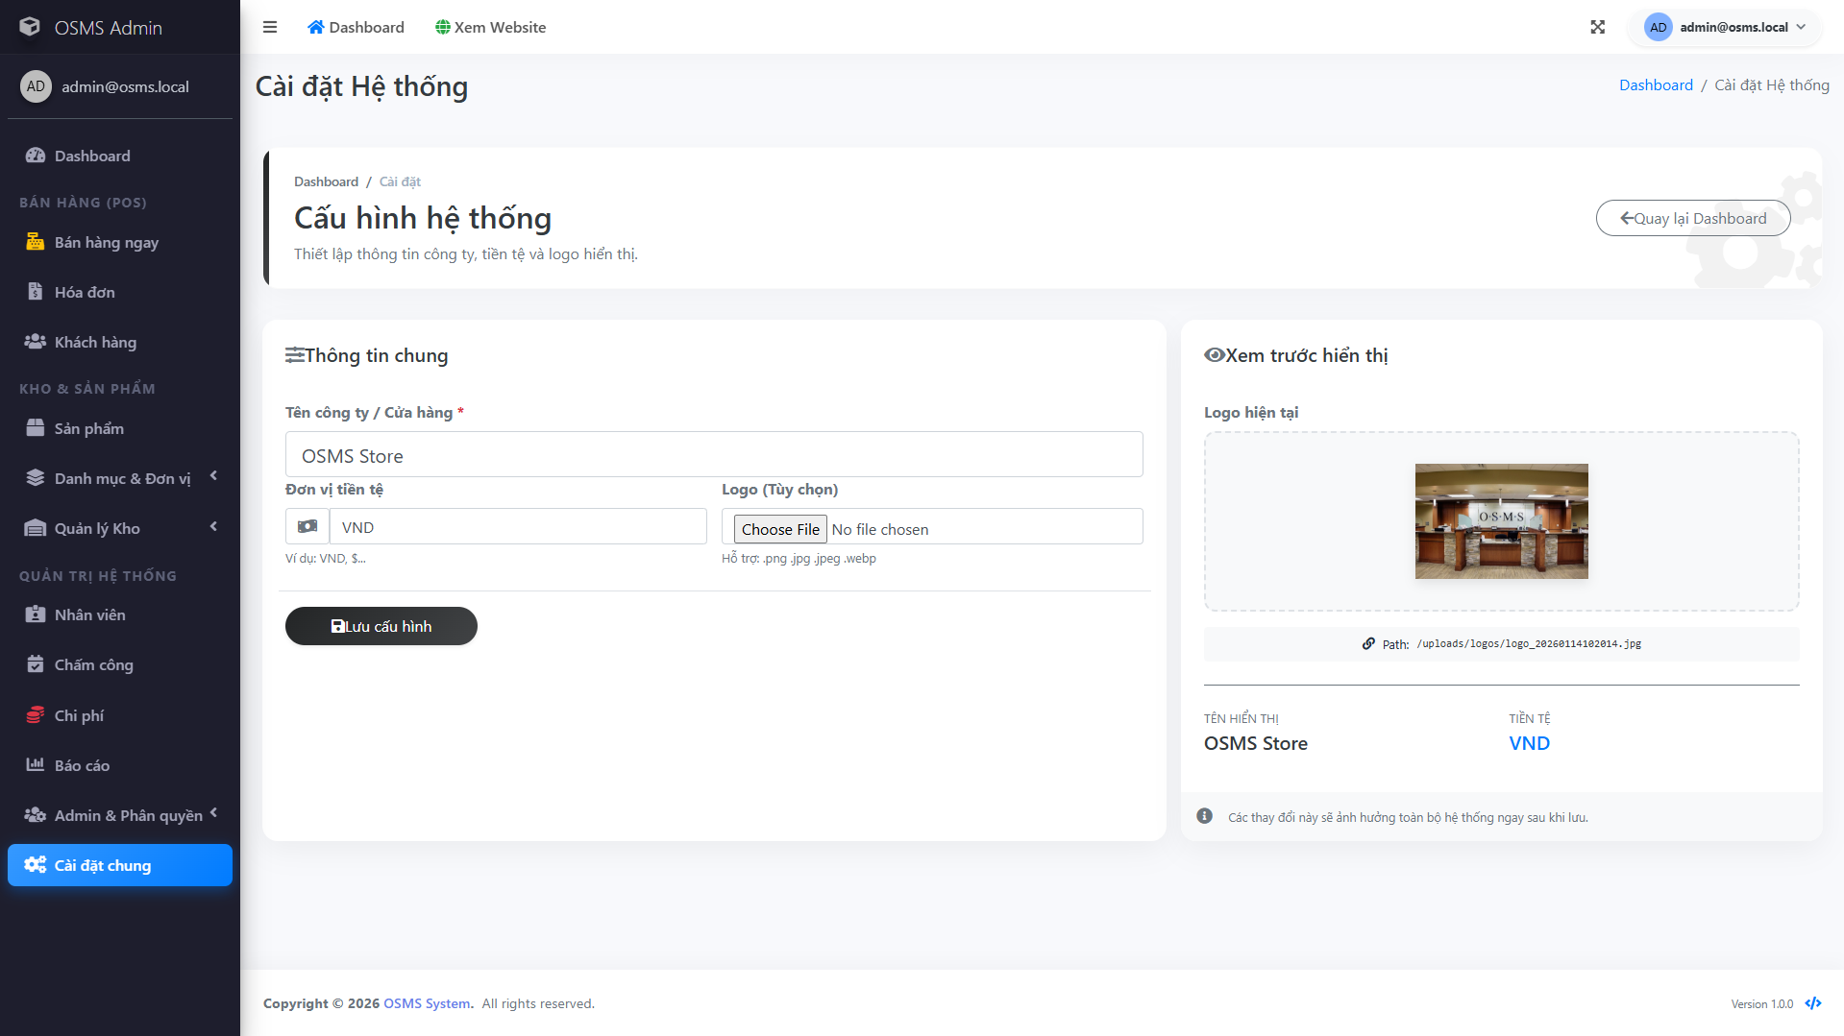
Figure ‎4.4-13: System settings and branding configuration
Allows administrators to configure general settings such as store information, logo, and display options so the system matches the business identity.

Sales Staff main features

Sales dashboard
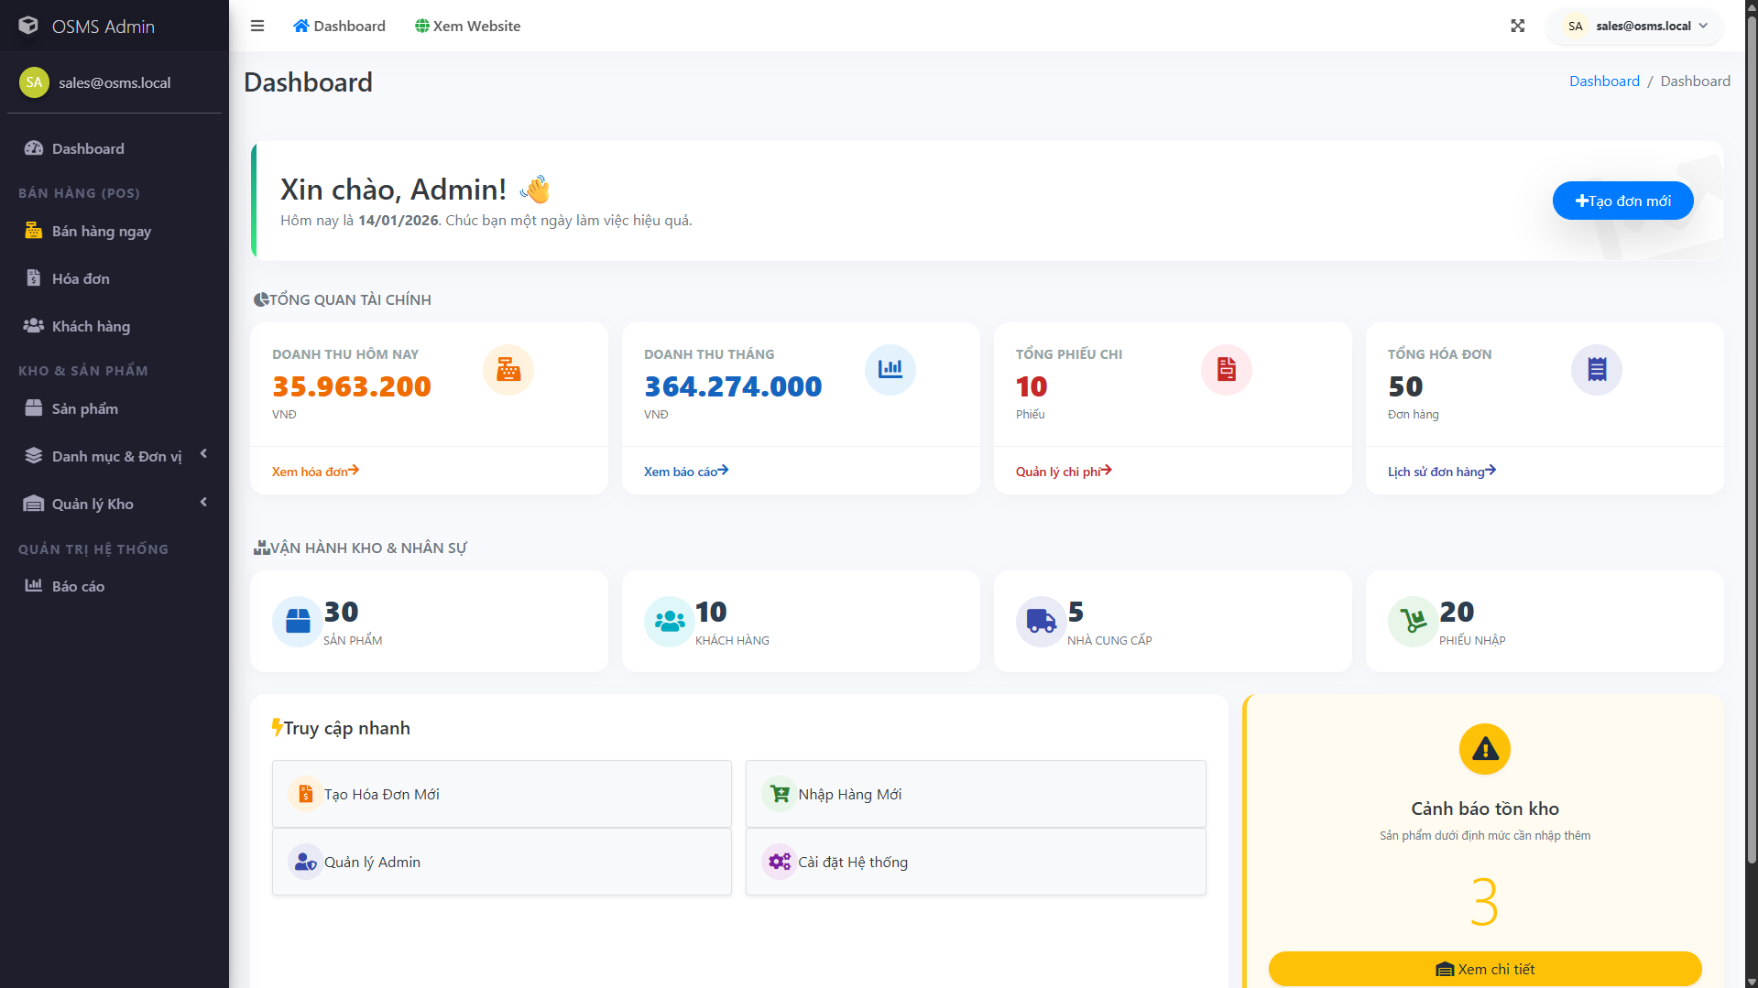
Figure ‎4.4-14: Sales dashboard
Sales landing page that supports daily work by summarizing sales-related activity and giving quick access to core sales modules.

Product browsing and searching
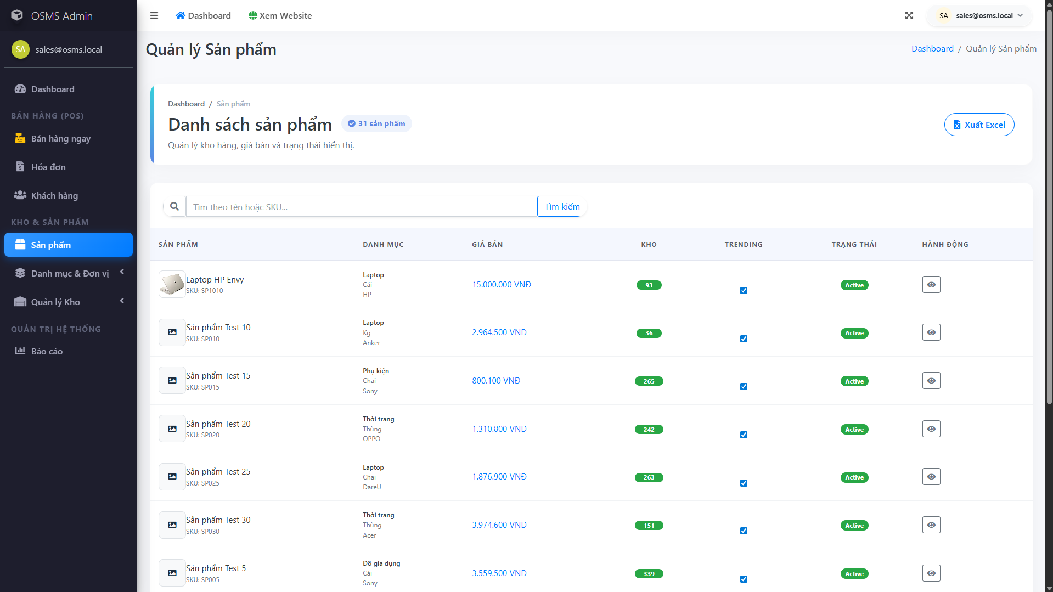
Figure ‎4.4-15: Product browsing and search
Shows the product list with search/filter controls, helping sales staff quickly find items during customer consultation.

Product detail view
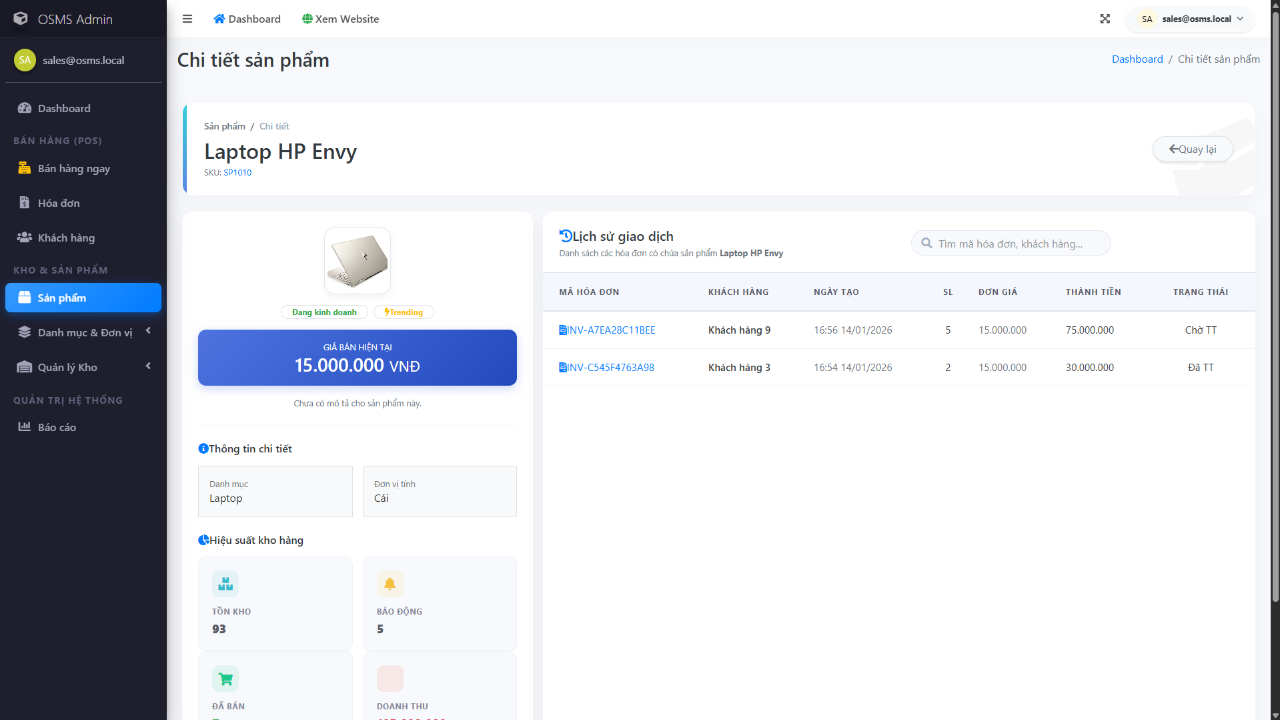
Figure ‎4.4-16: Product details
Displays full product information such as pricing and key attributes so staff can confirm the correct item before adding it to an invoice.

Customer management
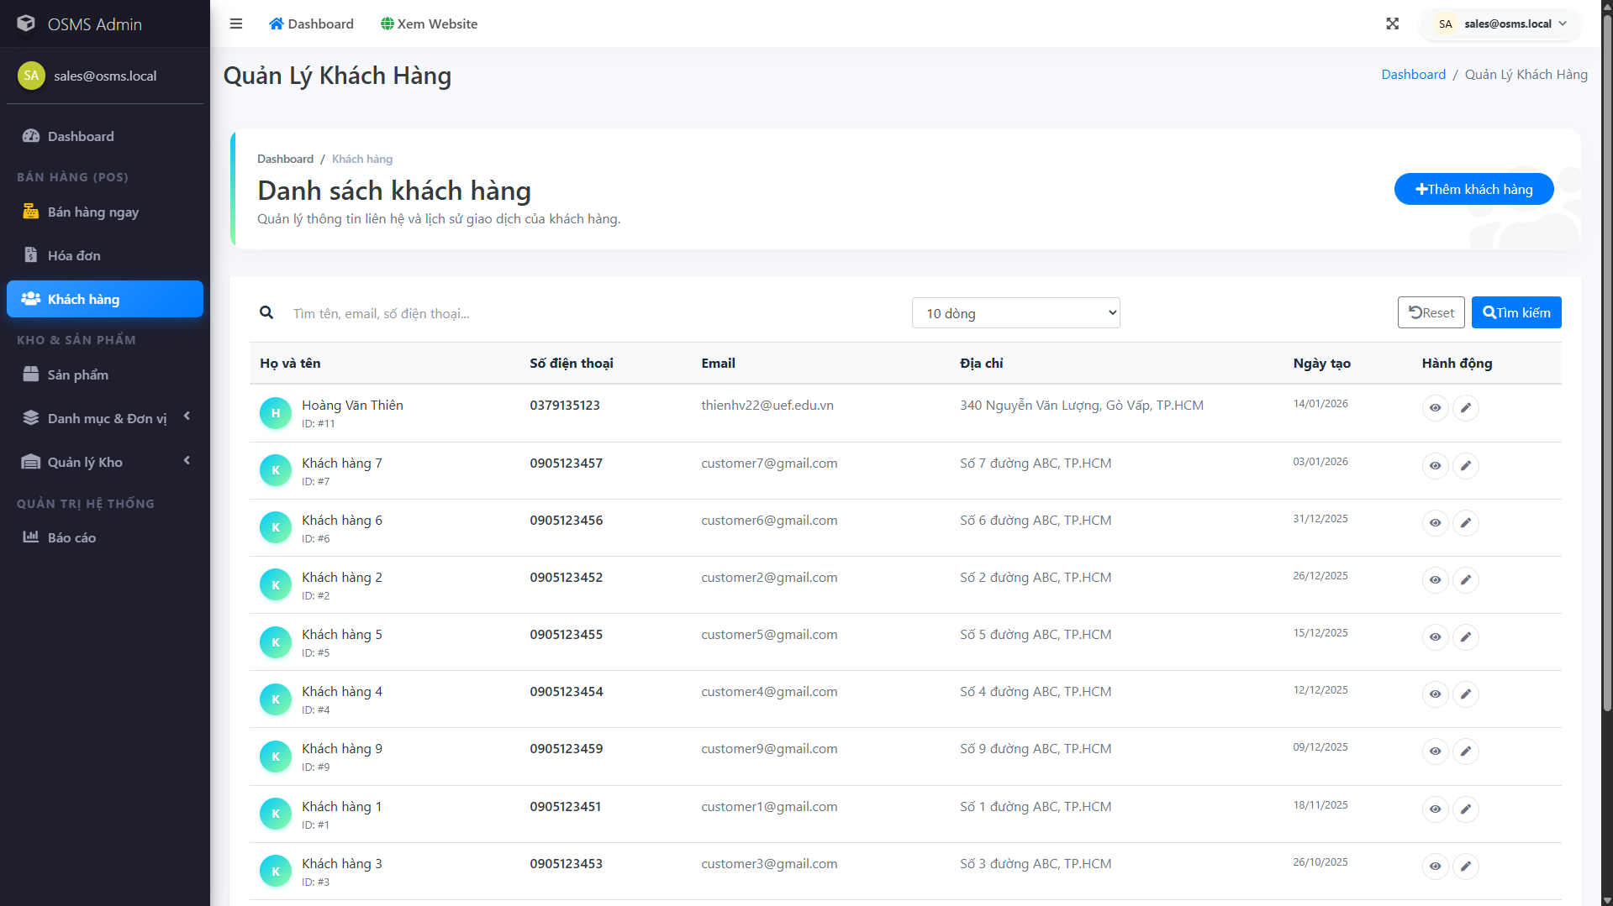
Figure ‎4.4-17: Customer list
Central customer directory for sales staff, supporting searching and selecting a customer for invoice creation.

Customer detail
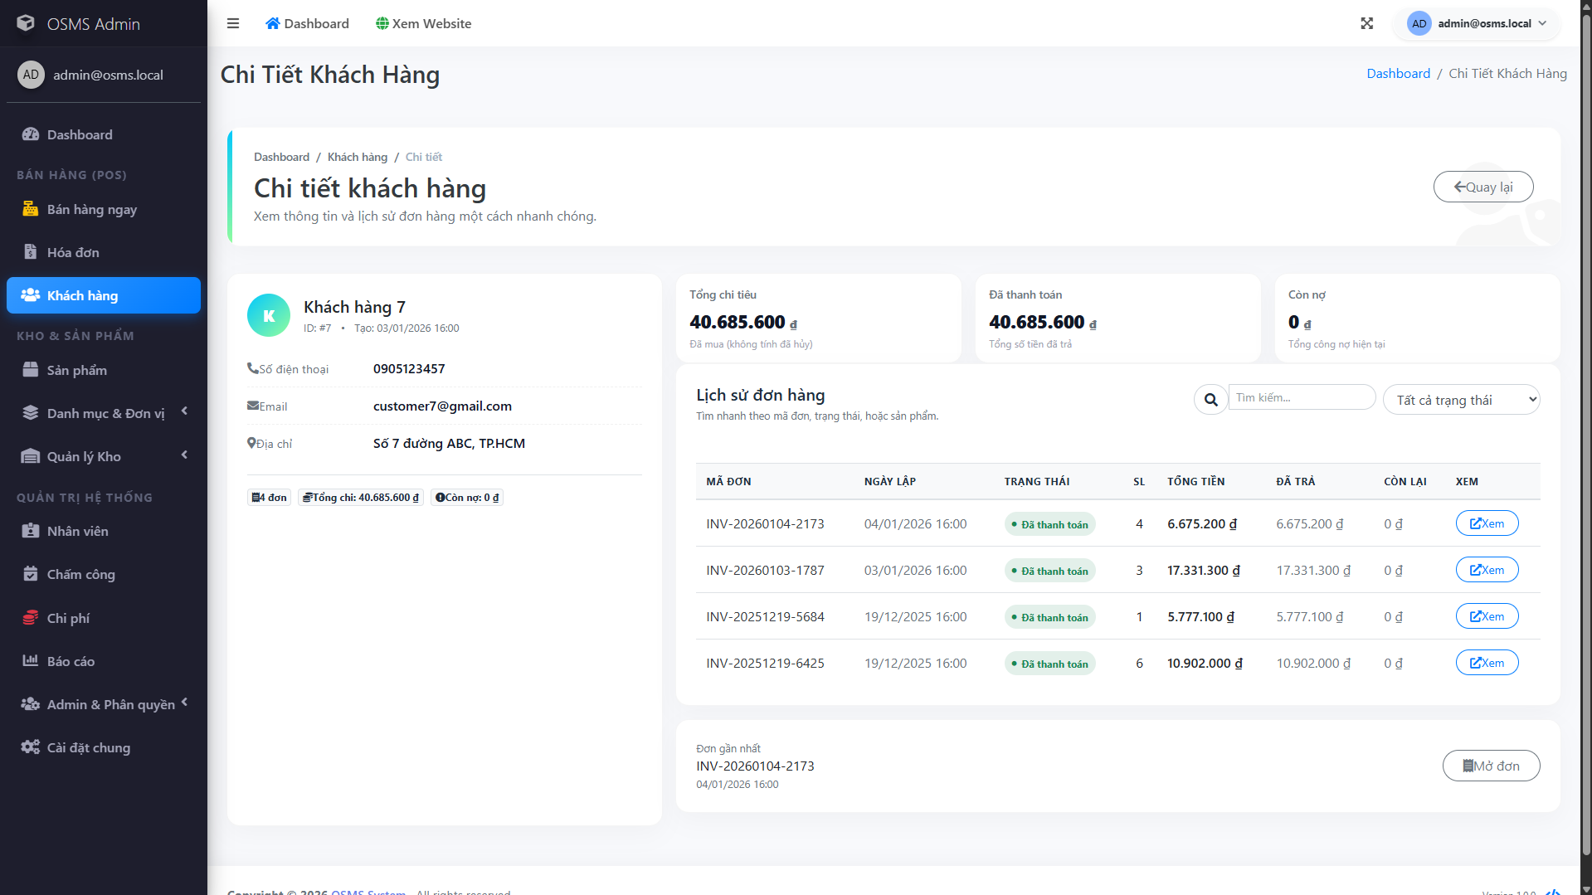
Figure ‎4.4-18: Customer detail
Shows a single customer profile with the stored contact information needed for sales processing and delivery coordination.

Customer create
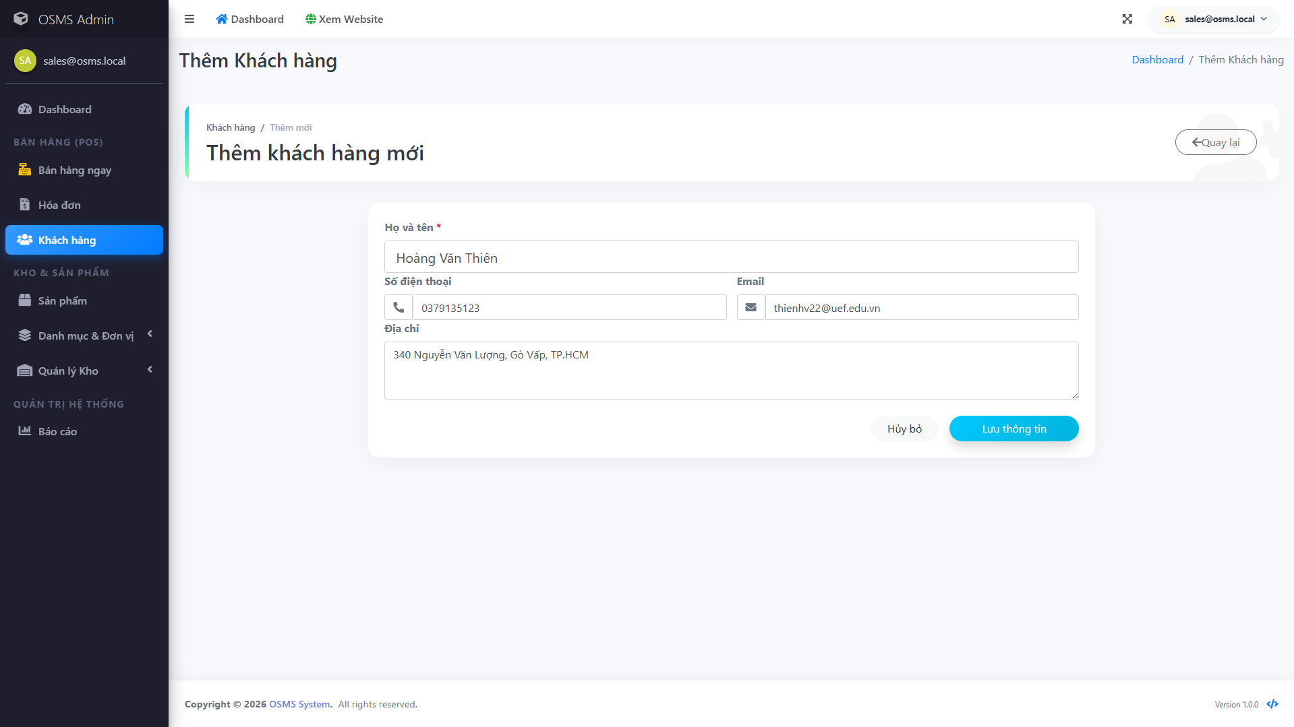
Figure ‎4.4-19: Customer create
Customer creation form used to register a new customer record when the buyer is not yet in the system.

Create invoice
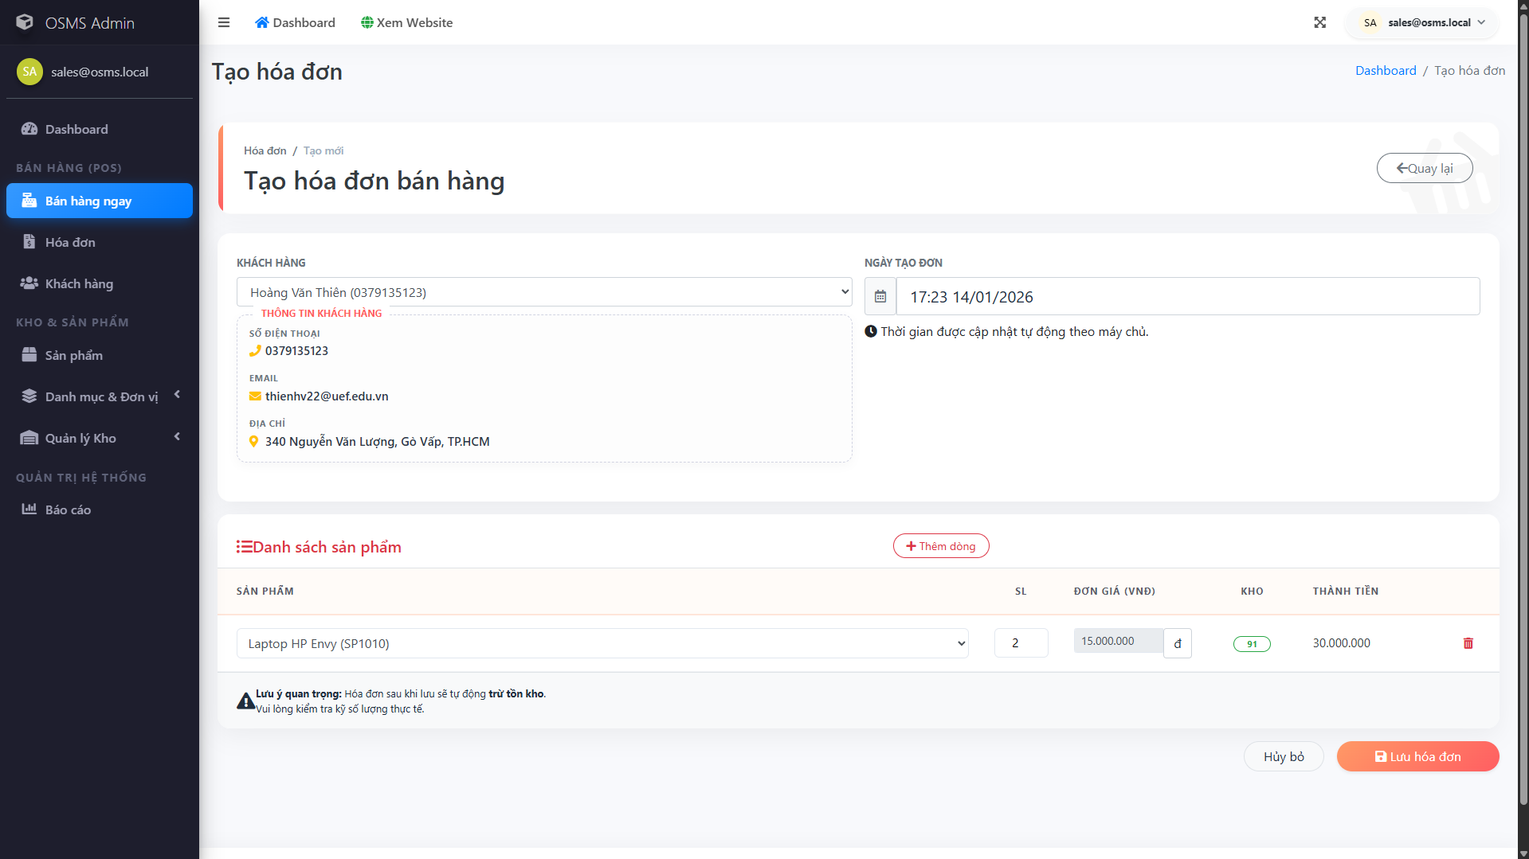
Figure ‎4.4-20: Create invoice
Invoice creation screen where staff select a customer, add products, and build a complete sales transaction.

Invoice calculation and total
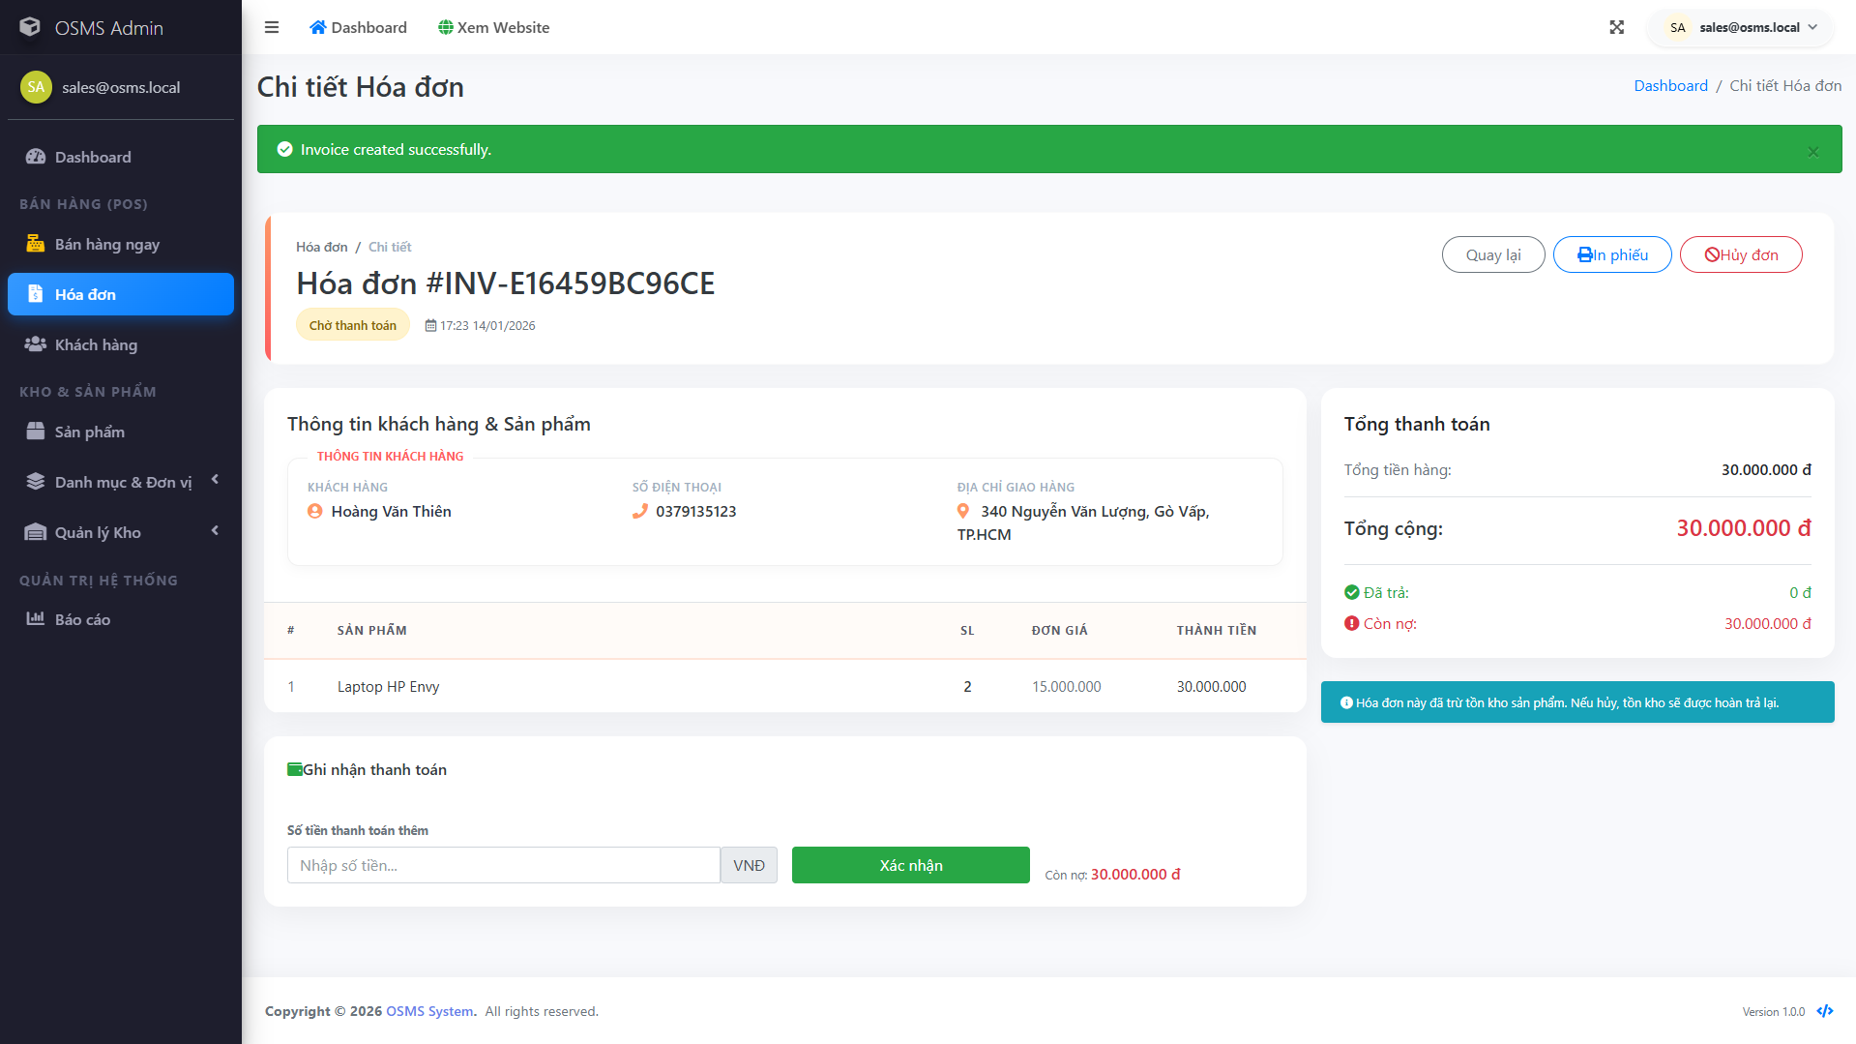
Figure ‎4.4-21: Invoice calculation and total
Demonstrates automatic calculations (line totals and overall totals) to reduce manual mistakes and keep billing consistent.

Invoice status workflow
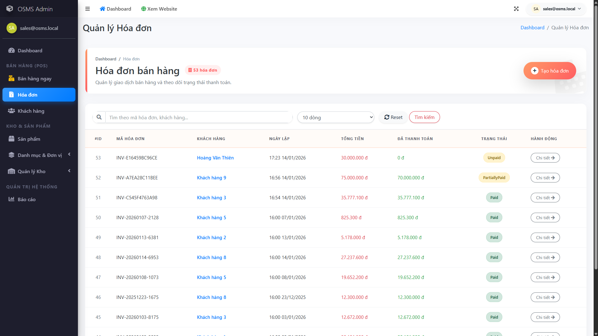
Figure ‎4.4-22: Invoice unpaid status
Shows the workflow state when payment has not been received, helping staff track outstanding invoices.
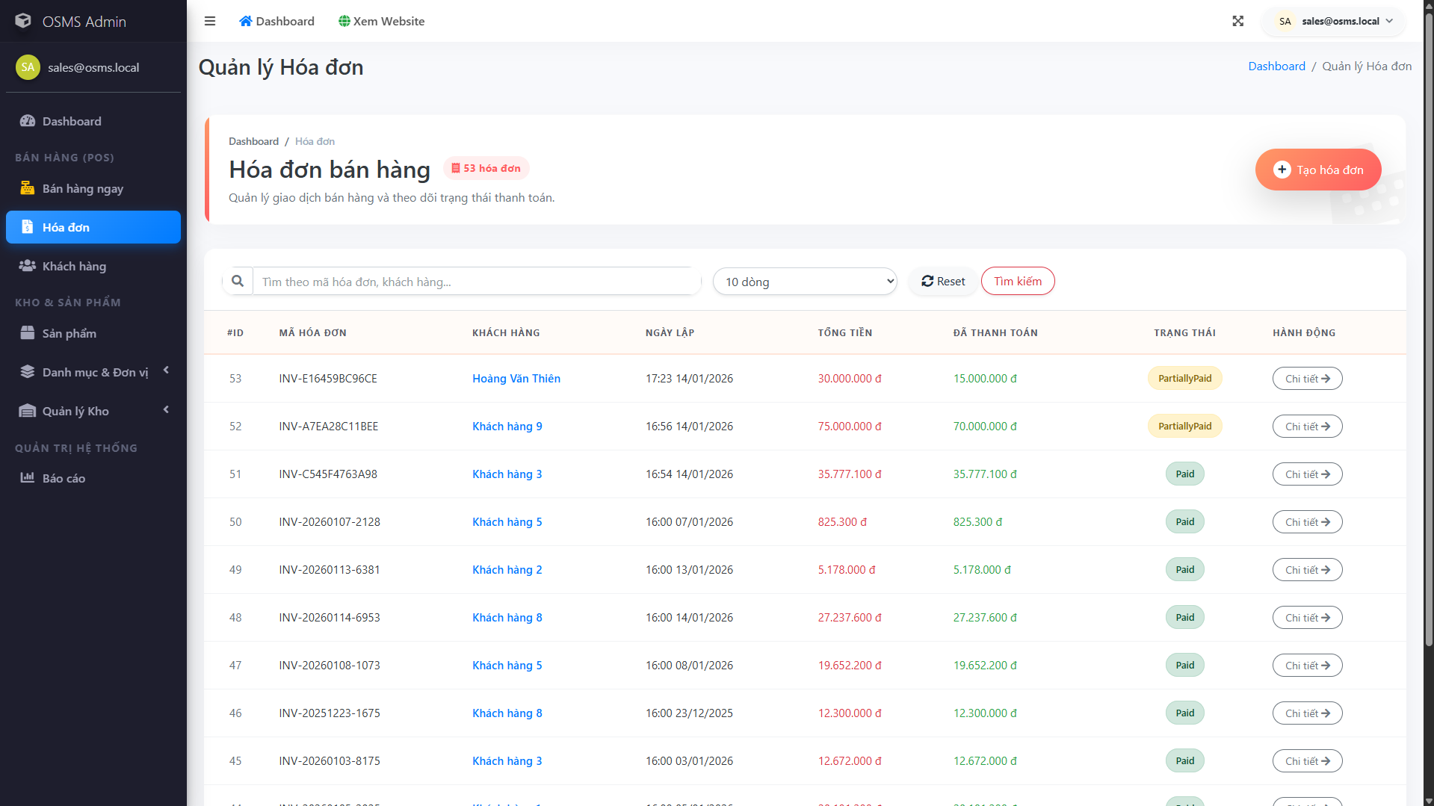
Figure ‎4.4-23: Invoice partially paid status
Represents an invoice with partial payment recorded, supporting incremental payments while keeping the remaining balance visible.
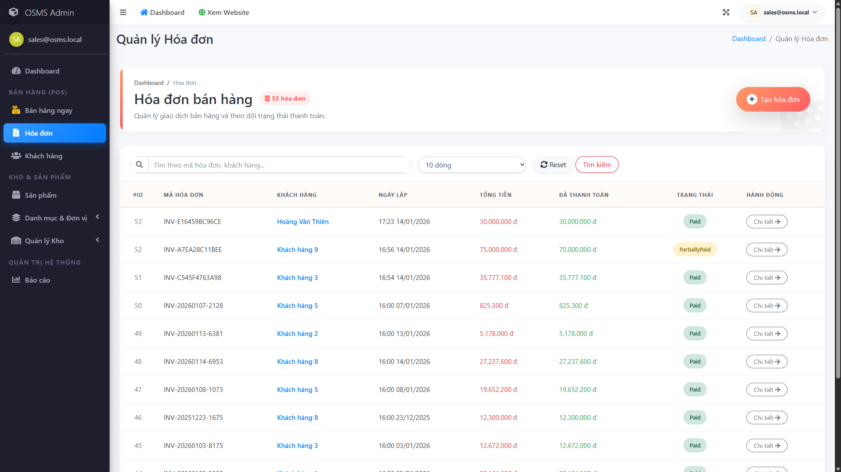
Figure ‎4.4-24: Invoice paid status
Indicates the invoice is fully settled, which helps finalize the transaction and supports accurate revenue reporting.
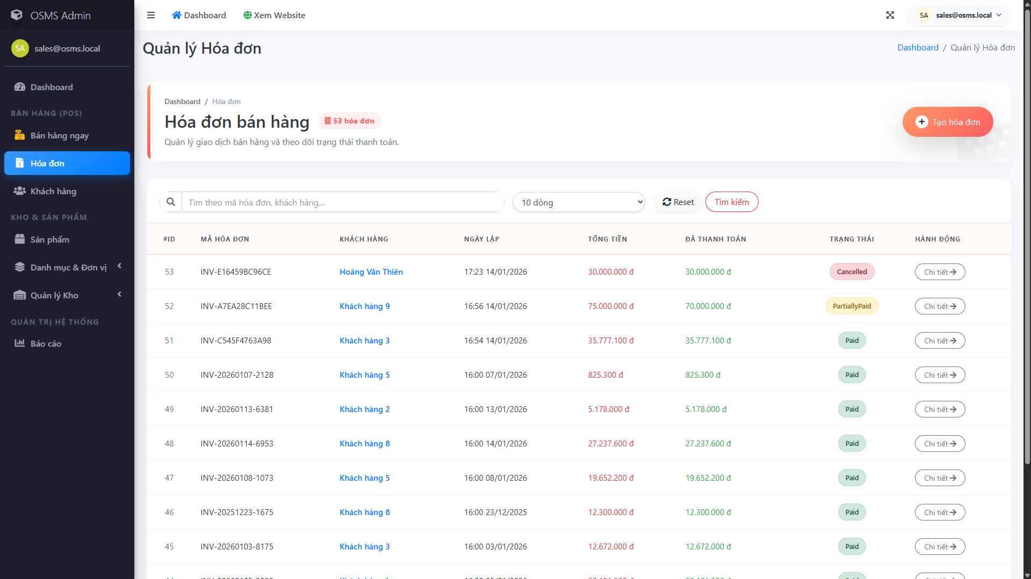
Figure ‎4.4-25: Invoice cancelled status
Shows how the system marks an invoice as cancelled to prevent it from being processed as revenue and to keep an audit trail.

Print invoice
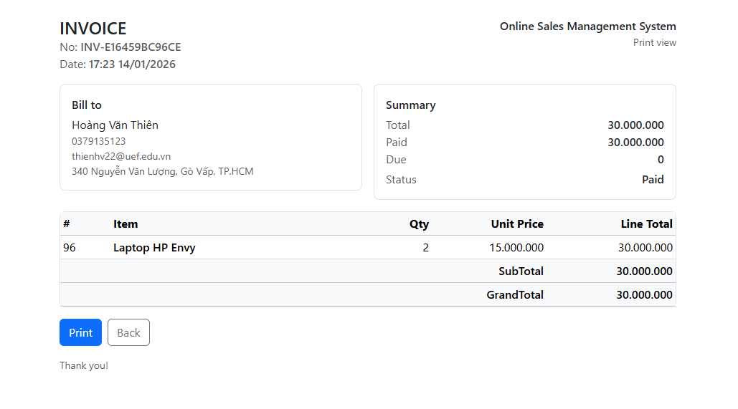
Figure ‎4.4-26: Print invoice
Print-friendly invoice layout used to provide a physical copy or a clear printable format for the customer.

Error handling and validation
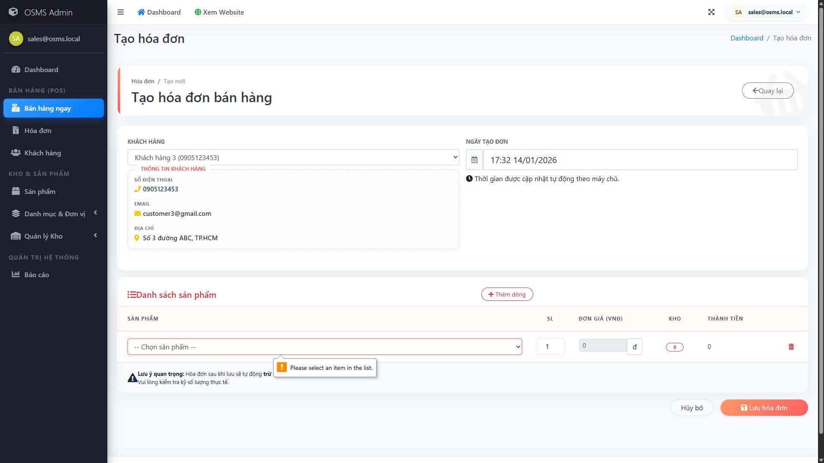
Figure ‎4.4-27: Error handling and validation
Example of validation feedback when inputs are missing or invalid, ensuring data quality before saving changes.

Warehouse main features

Warehouse dashboard overview
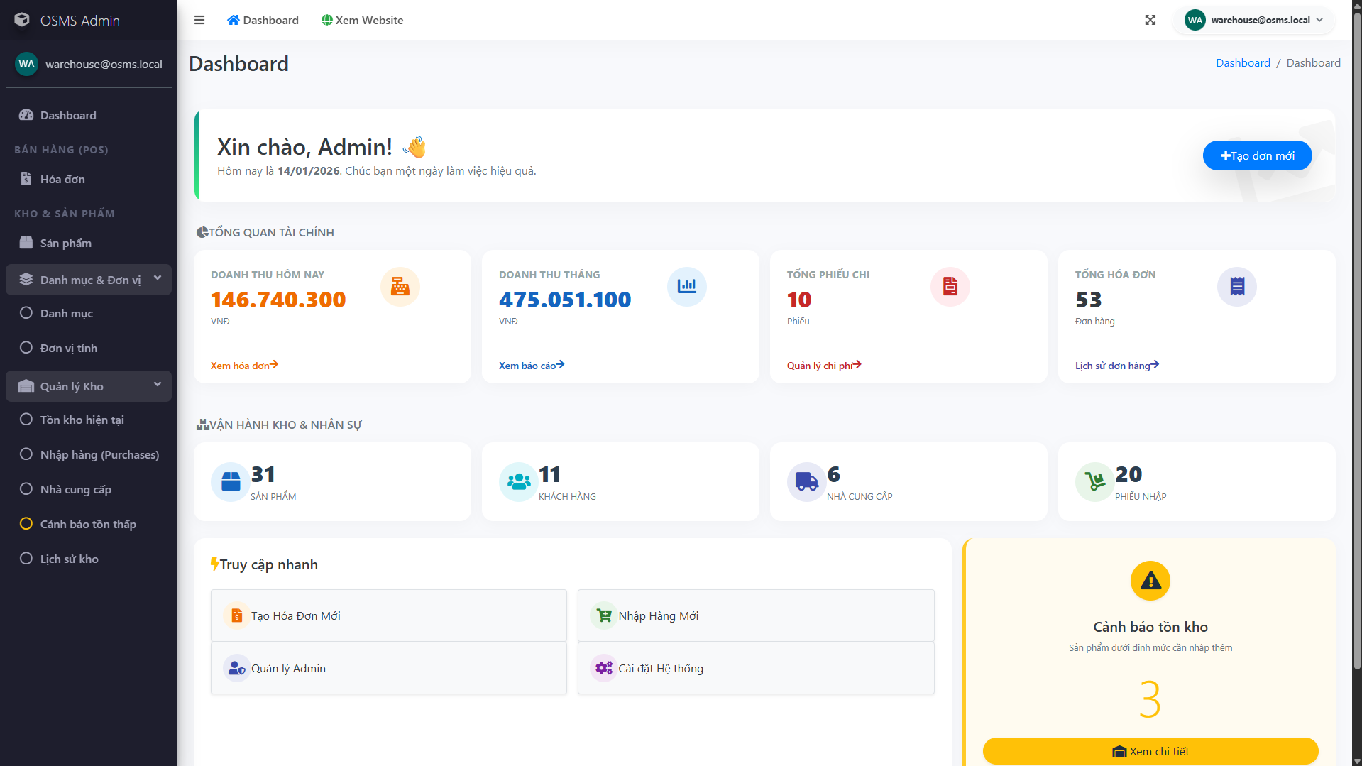
Figure ‎4.4-28: Warehouse dashboard
Warehouse landing page that highlights inventory-related work and provides quick access to stock operations.

Inventory monitoring
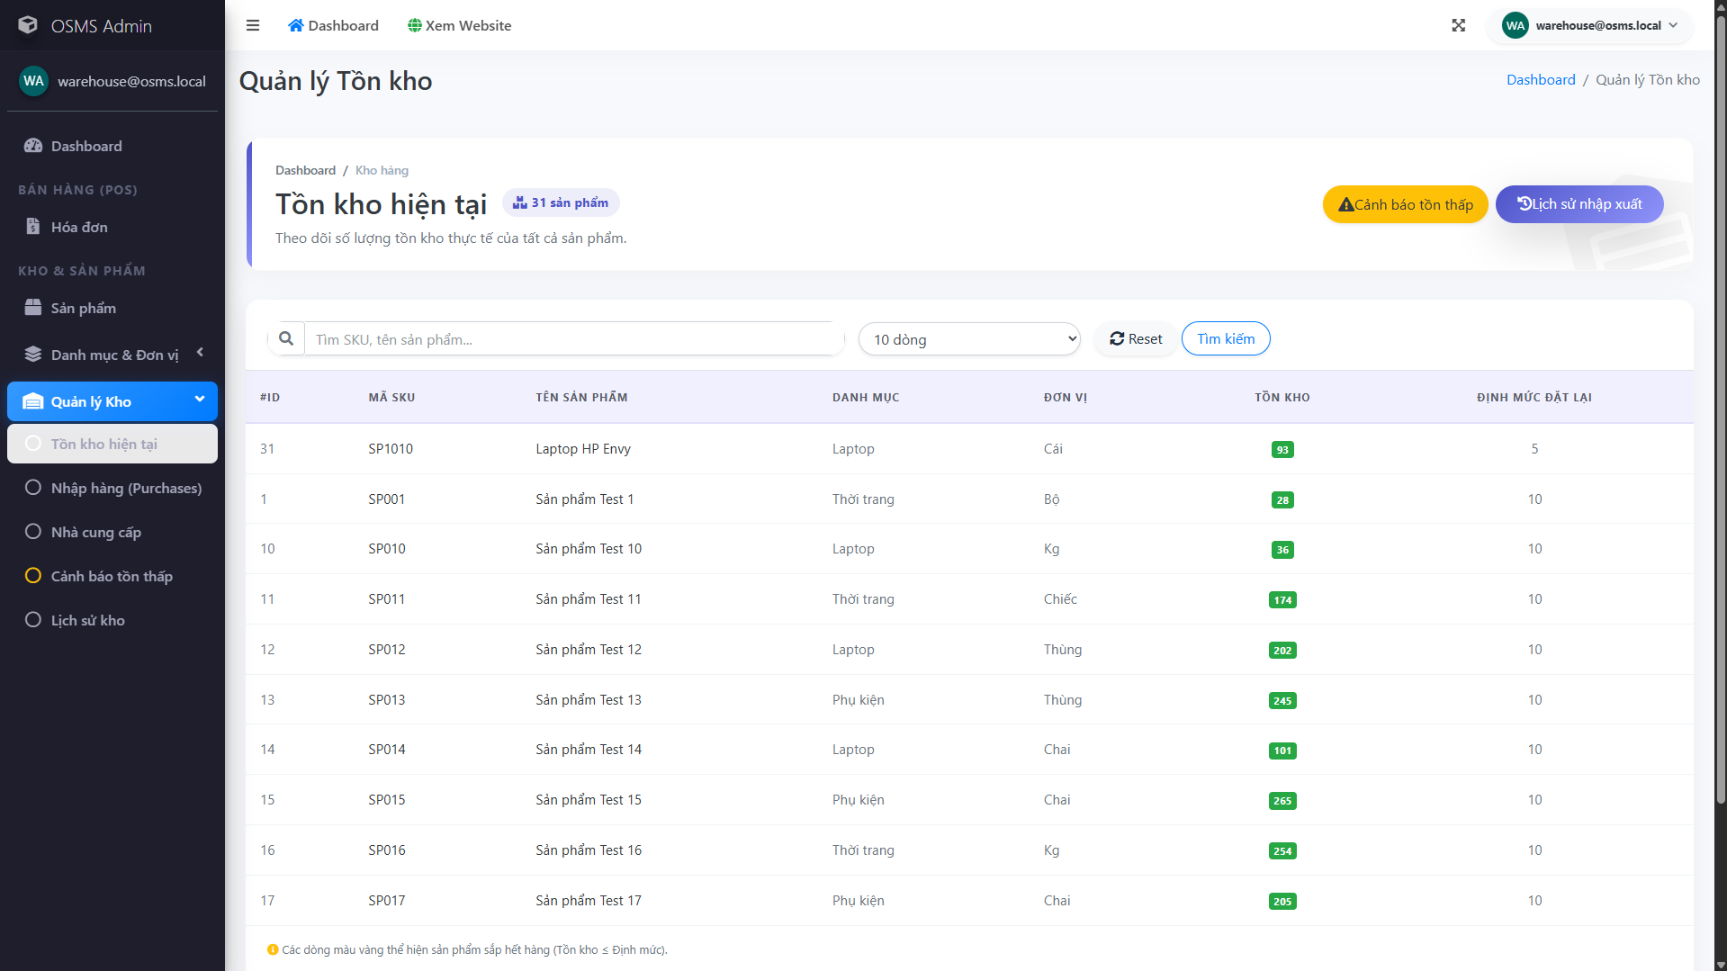
Figure ‎4.4-29: Inventory monitoring
Shows the current inventory view used to monitor stock levels across products and detect shortages early.

Create stock import receipt
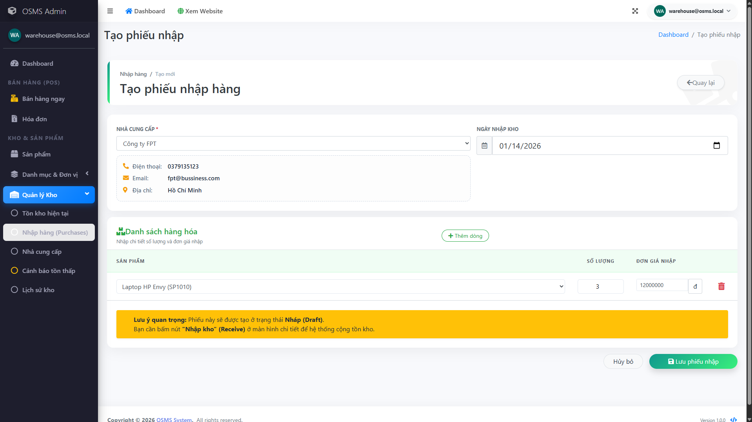
Figure ‎4.4-30: Create stock import receipt
Stock import screen where warehouse staff record incoming goods, quantities, and receipt details to update inventory accurately.

Inventory updated after import
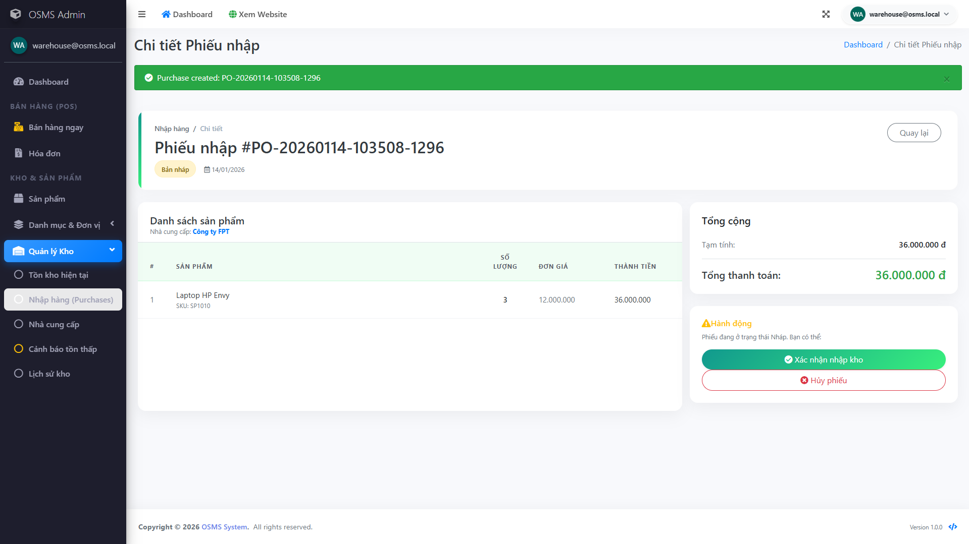
Figure ‎4.4-31: Inventory updated after import
Confirms that inventory quantities change immediately after a successful import, reflecting real-time stock updates.

Stock movements history
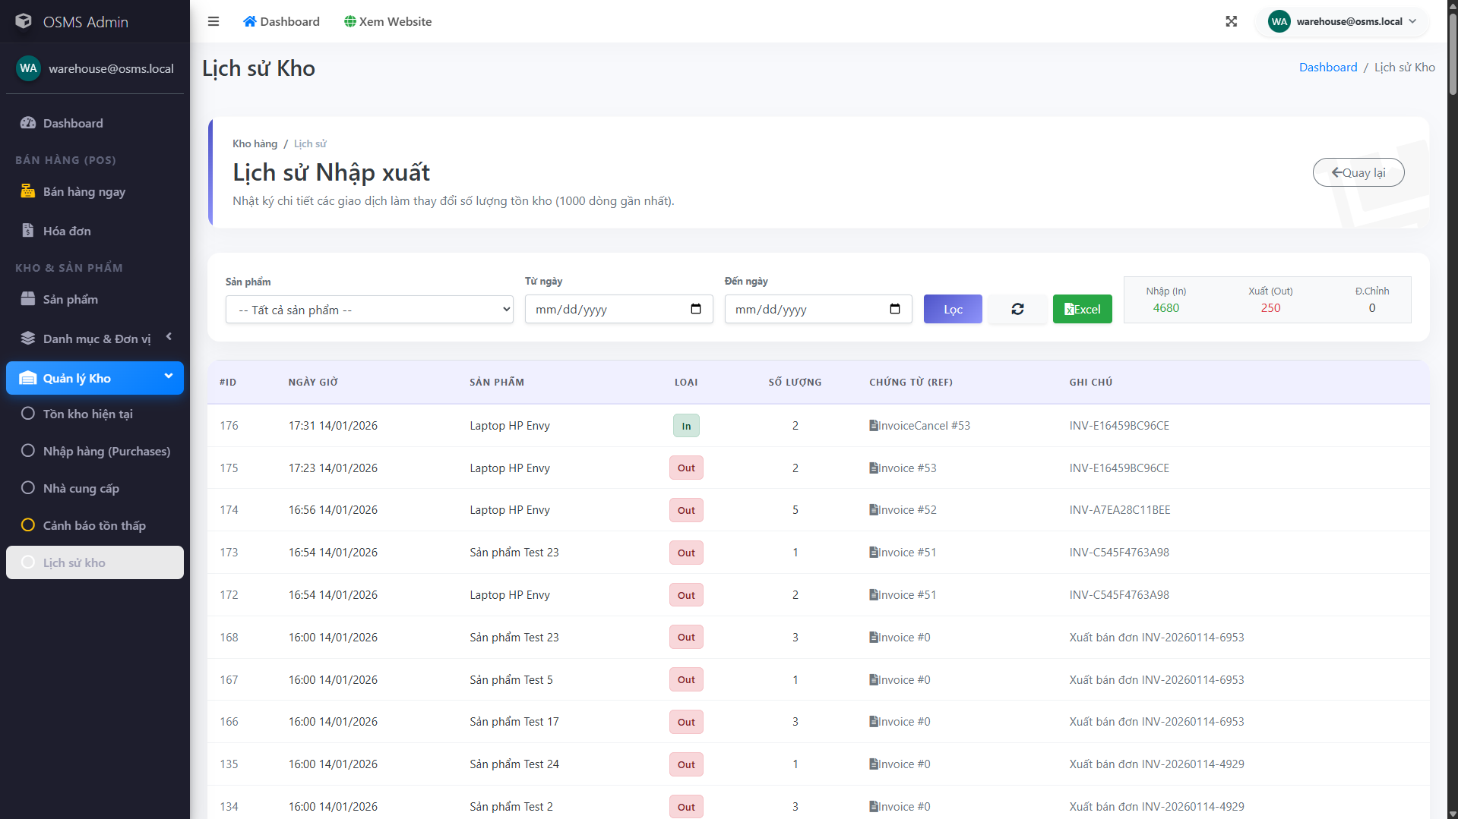
Figure ‎4.4-32: Stock movements history
Tracks inventory movements over time, supporting auditing and helping staff verify what changed and when.

Stock reorder alert
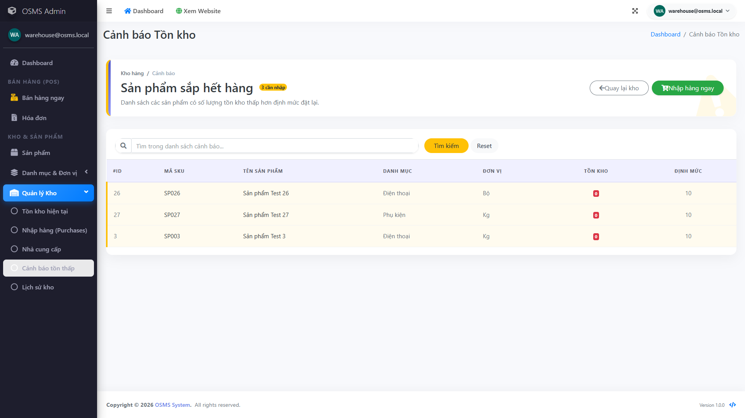
Figure ‎4.4-33: Stock reorder alert
Low-stock warning list that flags items nearing the reorder threshold so the warehouse can restock before shortages happen.

CONCLUSION AND FUTURE WORK

Achievements
Throughout the development of the Online Sales Management System, our team successfully delivered a functional web application that meets the core requirements of the course in terms of architecture, database integration, security, and usability. The following achievements summarize the key outcomes of the project:
First, we built a complete ASP.NET Core MVC web application with database connectivity. The system follows the MVC architecture to ensure a clear separation of concerns between Controllers, Views, and Models, which improves maintainability and supports future extension. The application connects to Microsoft SQL Server and performs data operations through Entity Framework Core, allowing consistent and efficient CRUD handling across modules.
Second, we implemented role-based security with a dynamic permission management mechanism. Beyond basic role separation (Admin, Sales Staff, Warehouse Staff), the system includes a dynamic permission matrix that enables administrators to grant or revoke actions (such as Show, Create, Edit, Delete, and other operational rights) per module. This design follows the principle of least privilege and helps prevent unauthorized actions. The RBAC mechanism is enforced at the backend level through a custom authorization approach (e.g., attribute-based protection), and the project also includes a practical verification scenario using a restricted test account to confirm real-time access denial behavior.
Third, we delivered essential business workflows for internal sales operations. The Sales Staff workflow supports product search, customer management, invoice creation, and invoice tracking. The system automatically calculates invoice totals and updates inventory after successful transactions, helping reduce manual errors. In parallel, the Warehouse workflow supports inventory monitoring and import goods processing, ensuring that stock levels are updated consistently and that stock movement history can be traced when needed.
Fourth, we designed a structured database schema aligned with real operational needs. The database design covers not only sales and inventory (products, categories, invoices, invoice items, purchases, purchase items, stock movements) but also supporting modules such as configuration and expense management. The schema applies relational constraints and relationship design (header-detail patterns for invoices and purchases) to maintain data consistency and support reporting queries.
Fifth, we produced full system documentation with diagrams and UI prototypes. The report includes a use-case diagram, activity diagrams, and sequence diagrams to explain key workflows. In addition, UI mockups were created in Figma to define layout conventions, component consistency, forms and validation behavior, and list/table patterns such as search, filtering, and pagination. This helped standardize user experience across Sales Staff, Warehouse, and Admin interfaces.
Finally, we provided a clear step-by-step installation guide and reproducible setup process. The implementation section documents how to clone the repository, configure the connection string, apply EF Core migrations, and run the application locally. This improves reproducibility and supports demo readiness, enabling the system to be deployed and tested consistently in different environments.
Overall, the project demonstrates our ability to analyze business workflows, design a structured database-backed web application, implement practical security controls, and document the system in a clear and logical manner according to the course report requirements.

Limitations
Although the Online Sales Management System successfully covers the core requirements of an internal sales and inventory management platform, the current version still has several limitations due to time constraints, academic scope, and resource availability.
First, the system is designed for internal operations rather than a public e-commerce storefront. At this stage, there is no end-customer interface for self-registration, browsing, or placing orders directly. All sales activities are handled through internal roles (Sales Staff, Warehouse Staff, and Admin), meaning customer interactions are mediated by staff instead of being performed by customers online.
Second, online payment and advanced transaction automation are not included. The system records invoices and payment status for management purposes, but it does not integrate with payment gateways (such as VNPay, MoMo, PayPal, etc.) or automate payment confirmation. As a result, some transaction steps still rely on manual updates, which may reduce efficiency for real-world deployment at scale.
Third, platform support is currently limited to the web environment. The application is implemented as a web-based system and does not provide native mobile applications for Android or iOS. While the interface is built with Bootstrap to support responsive layouts, mobile usability is still constrained compared to dedicated native apps, especially for warehouse tasks that may require faster scanning or on-device workflows.
Fourth, reporting and analytics remain basic compared to real enterprise requirements. The current reporting functions focus on essential statistics (e.g., revenue summaries within a selected period) but do not yet provide deeper analytical capabilities such as forecasting, demand prediction, automated replenishment suggestions, or advanced dashboards with drill-down insights. These features were considered but reserved for future work.
Finally, the current project scope prioritizes functionality and demonstration readiness over exhaustive testing and optimization. Due to limited time, the system has not been fully evaluated with large datasets, high concurrent traffic, or comprehensive test automation (unit tests/integration tests). Performance tuning, security hardening beyond the implemented RBAC mechanism, and production deployment practices would be necessary before applying the system in a real commercial environment.
In summary, these limitations reflect the realistic constraints of a semester-based academic project. However, the current version provides a stable foundation for future enhancements and potential expansion toward a full-scale online sales platform.

Suggestions for future enhancements
To further improve the Online Sales Management System and address the current limitations, several enhancements can be considered in future development. The system may be extended with a customer-facing interface that allows end users to browse products, place orders, and track order status, transforming the solution into a more complete e-commerce platform. In addition, integrating online payment gateways and automating order-related processes would improve operational efficiency and reduce manual handling.
Furthermore, mobile usability can be enhanced by optimizing the interface for mobile devices, especially for warehouse operations such as inventory checking and stock entry. The reporting module can also be expanded with more detailed dashboards, exportable reports, and advanced analytics to support better business decision-making. Finally, future work should focus on strengthening system reliability and security through comprehensive testing, performance optimization, and additional security measures such as audit logging and activity tracking. These improvements would help make the system more scalable and suitable for real-world deployment.

APPENDIX
- Project source code (github)
GitHub Repository: Online-Sales-Management-System
Description: This repository contains the full source code of the project, including backend, frontend, database scripts, and configuration files.
- Ux/ui design (figma)
Figma Design Link: Online-Sales-Management-System-Figma
Description: This Figma file presents the complete UI/UX design of the system, including wireframes, high-fidelity mockups, and user flows.
- Appendix X. AI/Tools usage statement
Tools used: Visual Studio, SQL Server, GitHub, Figma, draw.io…
Generative AI:
Used for: summarizing requirements, suggesting naming conventions, improving English grammar in report, code guidance.
Not used for: direct copy-paste of full modules without review.
Verification: manual testing + team review.

REFERENCES
Microsoft Learn. (2024, June 17). Overview of ASP.NET Core MVC.
Retrieved January 2026, from
https://learn.microsoft.com/en-us/aspnet/core/mvc/overview

Microsoft Learn. (2025, July 30). Overview of ASP.NET Core.
Retrieved January 2026, from
https://learn.microsoft.com/en-us/aspnet/core/overview

Microsoft Learn. (2025, November 11). Introduction to Identity on ASP.NET Core.
Retrieved January 2026, from
https://learn.microsoft.com/en-us/aspnet/core/security/authentication/identity

Microsoft Learn. (2023, January 12). Migrations overview (Entity Framework Core).
Retrieved January 2026, from
https://learn.microsoft.com/en-us/ef/core/managing-schemas/migrations

Microsoft Learn. (2024, November 12). Entity Framework Core documentation.
Retrieved January 2026, from
https://learn.microsoft.com/en-us/ef/core/

Bootstrap. (n.d.). Introduction to Bootstrap 5.
Retrieved January 2026, from
https://getbootstrap.com/docs/5.3/getting-started/introduction/

GitHub. (n.d.). GitHub documentation: About version control and collaboration.
Retrieved January 2026, from
https://docs.github.com/en/get-started/using-git/about-git

TASK DIVISION AND CONTRIBUTION SUMMARY
Member name | Assigned tasks | Workload contribution (%) | Completion status (%)
Hoàng Văn Thiên | Database schema, core backend architecture, business logic implementation, order and invoice processing workflow, frontend and backend integration, RBAC and permission system development, database interaction via EF Core, system configuration, bug fixing, and overall project coordination. report writing and formatting, documentation editing and proofreading. |  | 100%
Nguyễn Thành Đạt | Frontend and backend development, UI/UX design and implementation using Razor Views and Bootstrap, partial backend controllers and services, UI consistency refinement, testing, and layout optimization, report writing and formatting, documentation editing and proofreading. |  | 100%
Trần Ngọc Tân | Database schema support, ERD and UML diagrams preparation, documentation of system design, partial database setup assistance. Prepare presentation slides. |  | 100%
Trần Ngọc Diễm My | Report writing assistance, formatting and documentation editing. Prepare presentation slides. |  | 100%

